Operation Manual
Team 505
EML 4552: Senior Design II
Dr. McConomy
March 26, 2022

Project Overview
The RE-RASSOR is based on NASA’s RASSOR. This rover is engineered to mine in low gravity which will aid in space exploration and colonization. The RE-RASSOR is a scaled-down version of NASA’s original RASSOR that is used for educational purposes. Our project needs to be affordable and easily replicated. The rover uses two rotating drums attached to arms with shoulder joints to the body with four wheels. When the drums are co-planar to the ground and rotating, they propel the body downwards. The RE-RASSOR is using the same physics with the fraction of size and cost. Our projected scope is redesigning the shoulder joint and arm.

Component/Module Description
All Creo files can be downloaded at the link below:
https://drive.google.com/drive/folders/1Avh1IvApap6hp3sFqu2n_We7LlbtJ-01?usp=sharing
All STL files can be downloaded at the link below:
https://drive.google.com/drive/folders/1ramL2J5DWkxRTX-dNWjKdK5XjYMY8uas?usp=sharing
There are a total of 14 distinct parts that make up the shoulder joint; the parts are listed in the Bill of materials in Figure 1. 9 of the parts were 3D-printed and are shown in the drawings from Figures 2-11. The remaining 7 parts are the motor and the nuts and bolts that fasten the shoulder to the mount, motor mount, and the shoulder assembly. Below are instructions of how to recreate the drawings in Creo Parametric, convert them to STL files and slice them for printing.
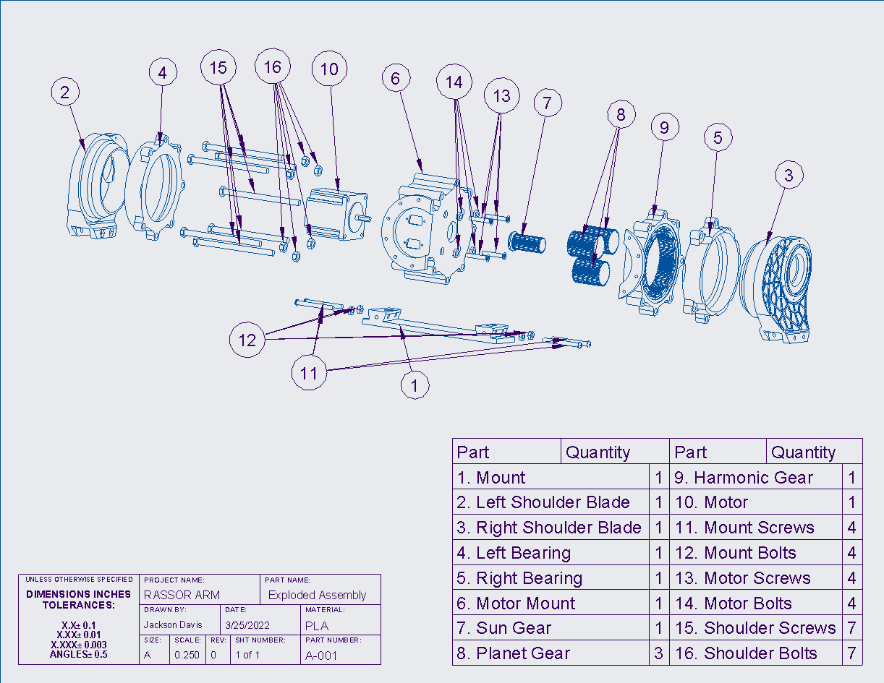
Figure 1: Exploded View and Bill of Materials
Below in Figure 4 is the mount for the shoulder joint, its dimensions are shown and can be used to recreate the part in Creo.
Creating the part in Creo starts by making a rectangular extrusion on the bottom plane. This is shown in Figures 2a and 2b. Next you can use the Sweep Blend tool to create the two flanges that the shoulder blades slide on. This is shown in Figure 2c. The mirror tool will be useful in this step shown in figure 2d. Finally, you can make the two holes by performing another extrusion on the top surface of the two flanges and using the round tool where necessary as shown in Figure 2e. Once the part is created you can save it shown in Figure 2e-f.
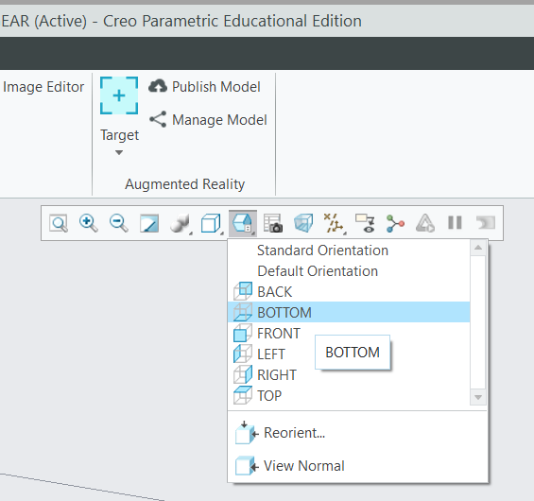
Figure 2a
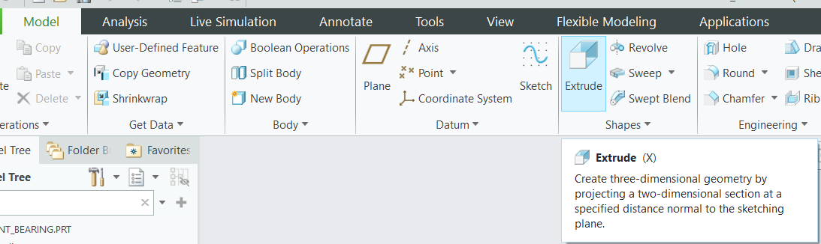
Figure 2b
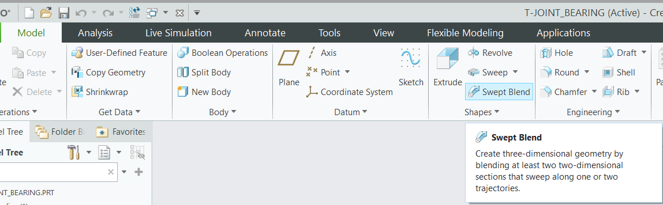
Figure 2c
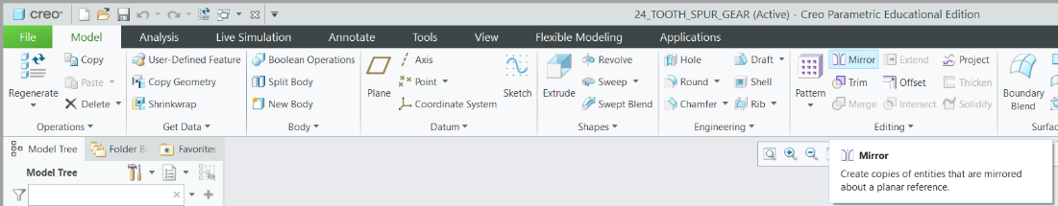
Figure 2d
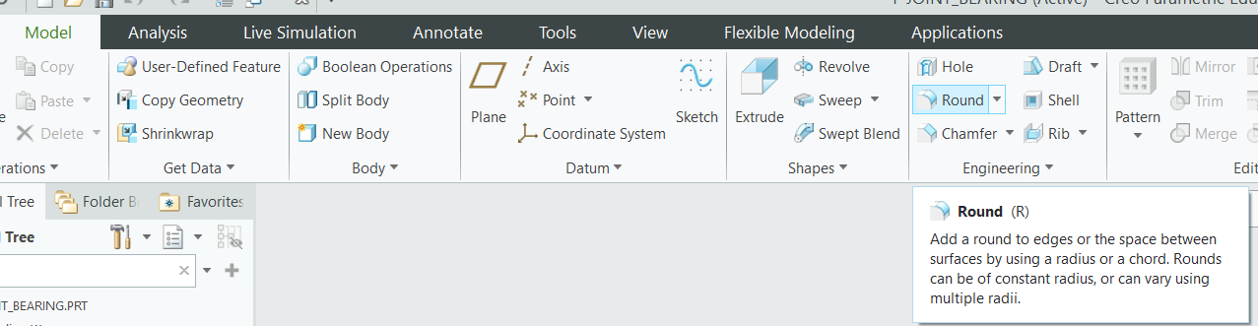
Figure 2e
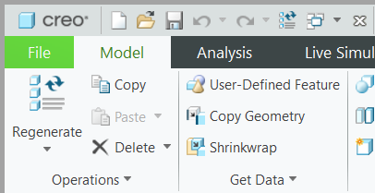
Figure 2f
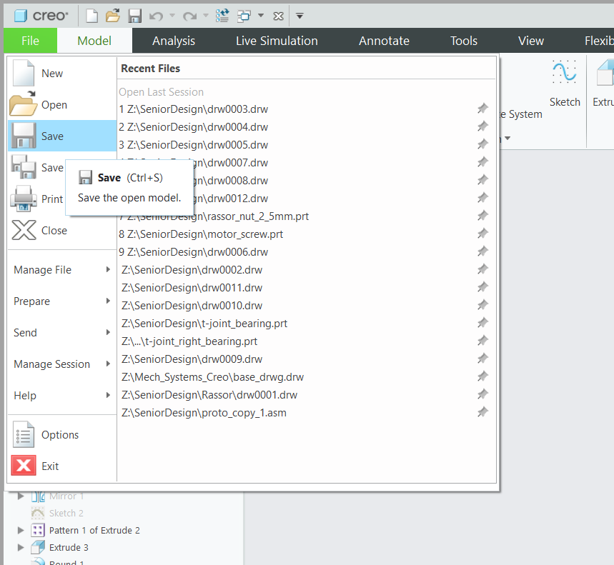
Figure 2g
After saving you can save a copy of the part and set it as an STL file shown in Figure 3a-c. From here you can upload the file to whatever slicing software you have. For this part you will set the layer thickness to whatever is appropriate for your printer, set the wall thickness to between 2.8 and 3.2 mm (about 0.13 in) and set the infill to 30%. This is the setting we used during testing. For this part support structures are needed for the holes in the flanges. Additionally, the part should be centered with the bottom of the part on the platform. The way the part is oriented is shown below in Figure 5.
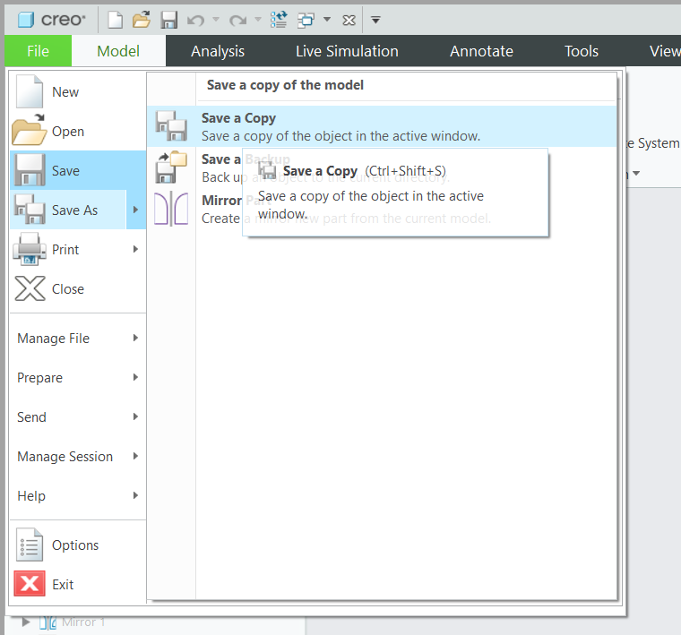
Figure 3a
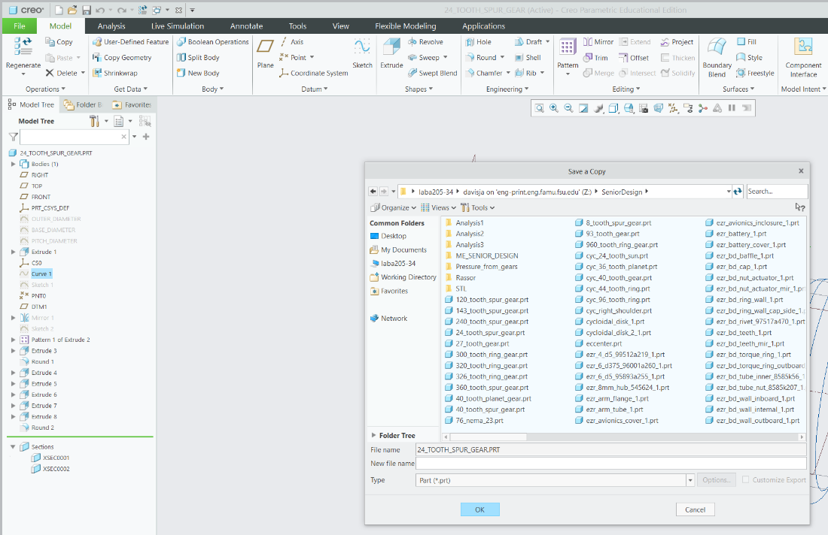
Figure 3b
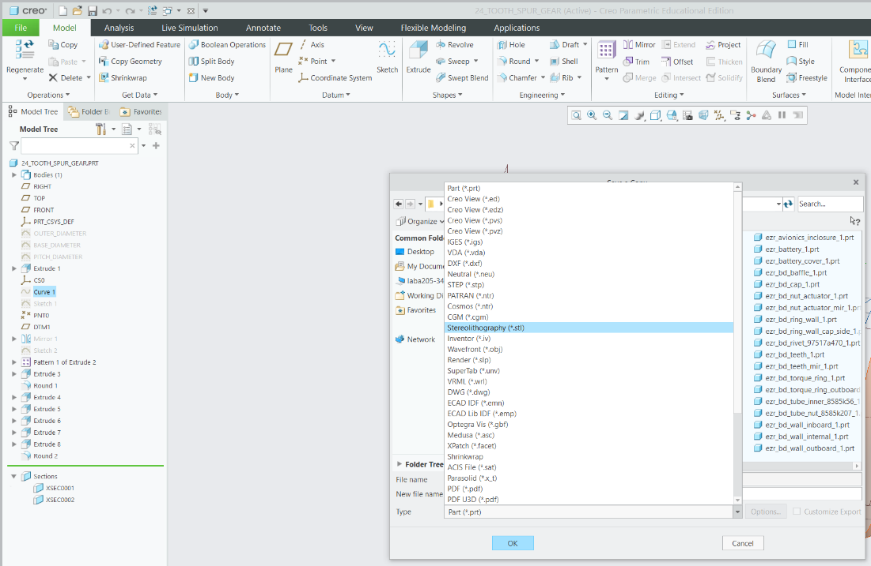
Figure 3c
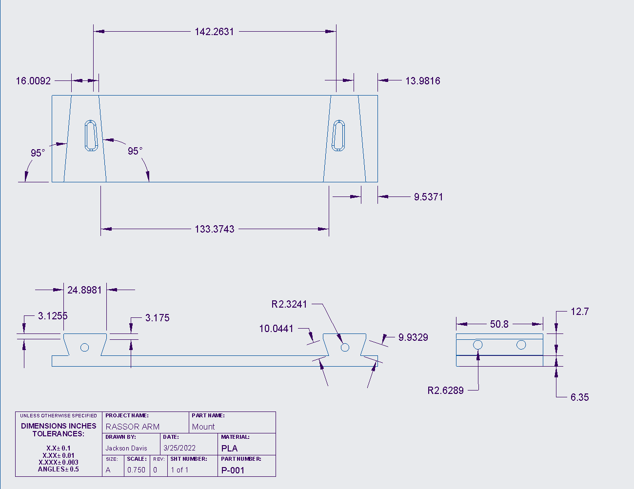
Figure 4: Part Drawing of the Mount
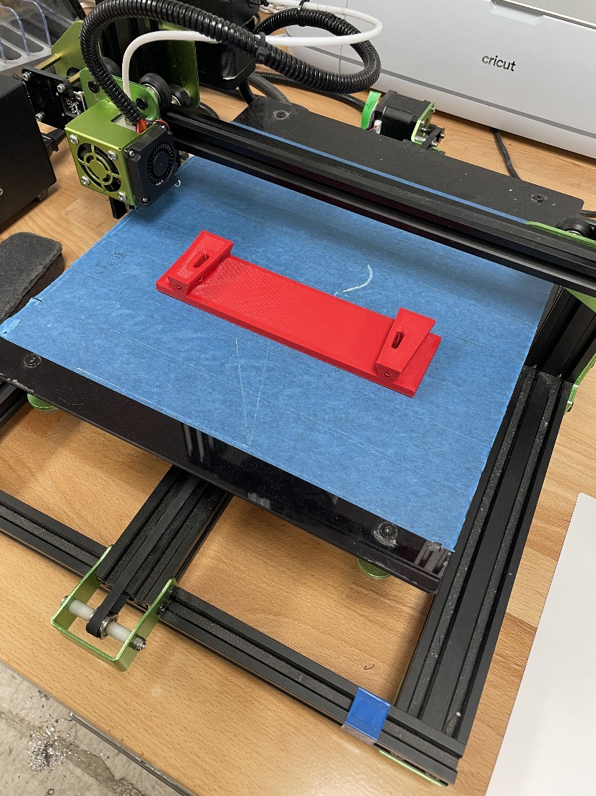
Figure 5: 3D-Print Layout for Mount
Below in Figures 7 and 8 is the Right Shoulder Blade, it serves as the guide on the opposing side of the gearbox and has a slot designed to allow the mount to slide into the shoulder blade. The part’s dimensions are shown and can be used to recreate the part in Creo.
Creating the part in Creo starts by selecting the bottom plane shown in Figure 2a and drawing the overall profile of the blade that can be seen if you look at the part from the front view shown in Figure 6a. Next you can select the drawing you just made and extrude it shown in Figure 2b. After the extrusion is made you can select different surfaces and make the proper extrusions to subtract material. You can also use the revolve tool to aid in removing material shown in Figure 6b. After the part is finished you can save it as shown in Figures 3a-c.
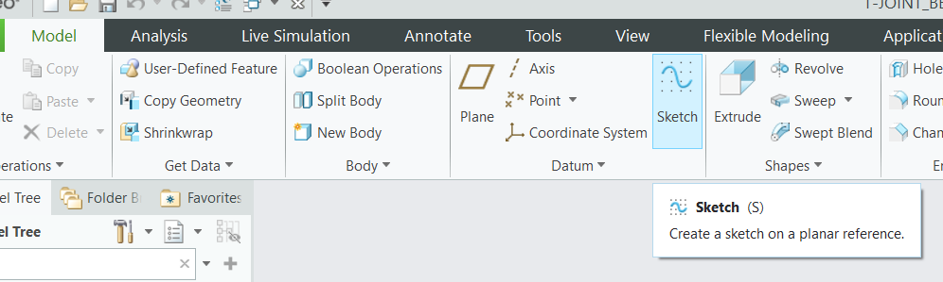
Figure 6a
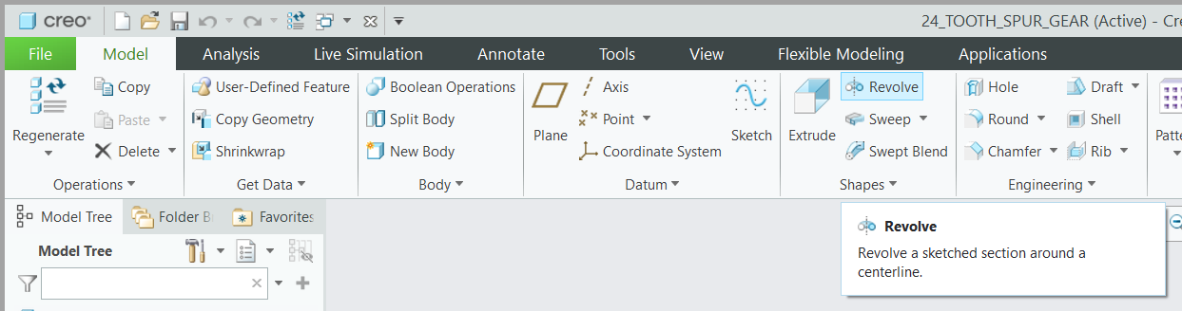
Figure 6b
After saving you can save a copy of the part and set it as an STL file shown in Figure 3a-c. From here you can upload the file to whatever slicing software you have. For this part you will set the layer thickness to whatever is appropriate for your printer, set the wall thickness to between 2.4 mm (about 0.09 in) and set the infill to 20-25%. This is the setting we used during testing. The reason for the drop in infill and wall thickness settings is since there is not as much stress on the part during its operation. For this part support structures are needed for the holes and to support the structure during the printing process. This part should be centered with the bottom of the part on the platform. The way the part is oriented is shown below in Figure 9.

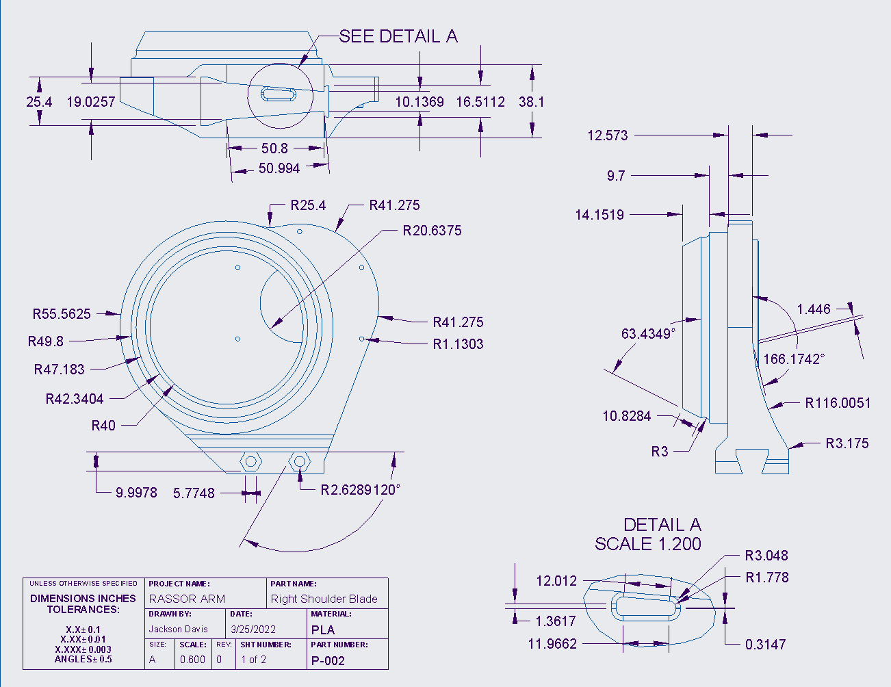
Figure 7: Drawing 1 of the Right Shoulder Blade
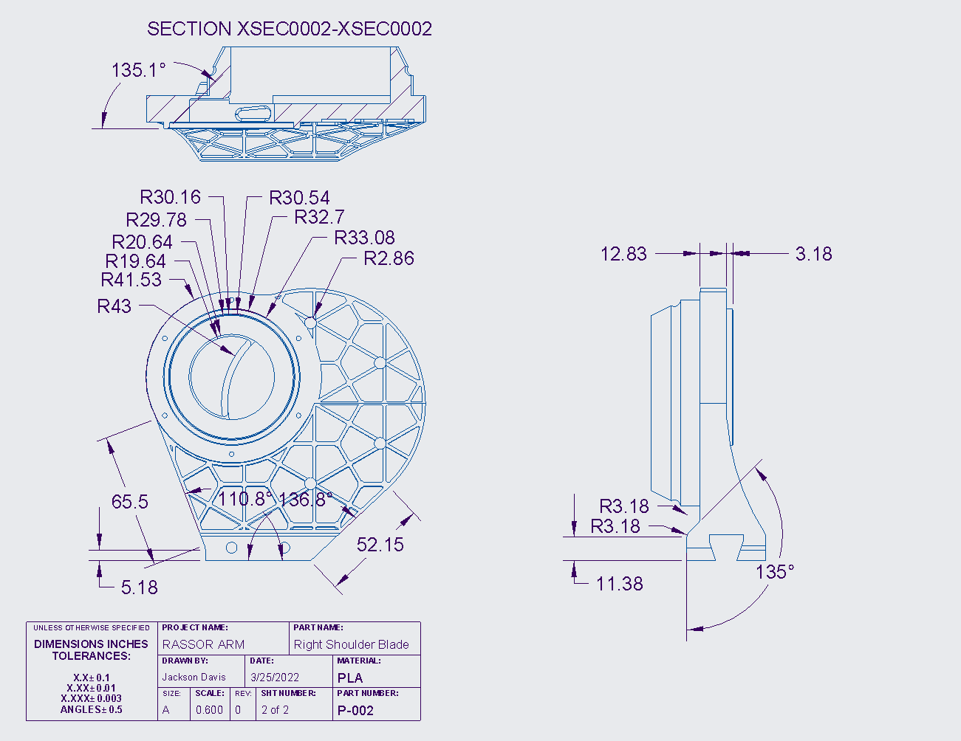
Figure 8: Drawing 2 of the Right Shoulder Blade
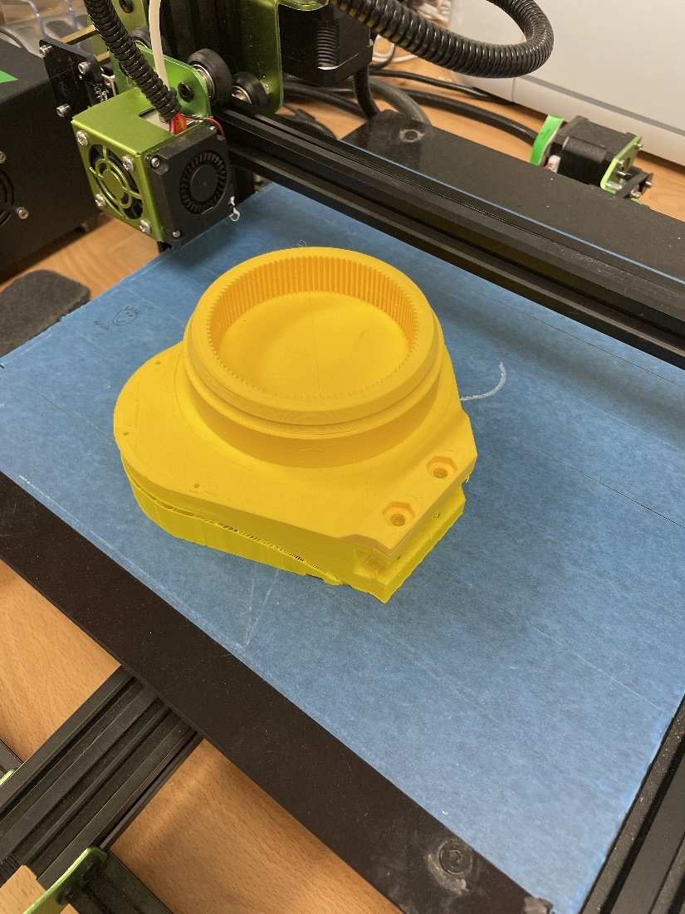
Figure 9: 3d-Print Layout for Right Shoulder Blade
Below in Figure 11 is the Left Shoulder Blade, it serves as the ground for our gearbox and has a slot designed to allow the mount to slide into the shoulder blade. The part’s dimensions are shown and can be used to recreate the part in Creo.
Creating the part in Creo starts by selecting the bottom plane and drawing the overall profile of the blade that can be seen if you look at the part from the front. Next you can select the drawing you just made and extrude it. After the extrusion is made you can select different surfaces and make the proper extrusions to subtract material. You can also use the revolve tool to aid in removing material.
At this point you can upload the parameters given at the bottom of the note on the drawing by selecting the tool tab and then selecting parameters Shown in Figure 10a and c. Then you can set the relations which are given at the top of the note by selecting the tool tab again and selecting relations after shown in Figure 10d. From here you can use these parameters to make the outer diameter, root diameter, pitch diameter, and base diameter. With these diameters you can use the datum line tool to create an involute profile for the teeth shown in Figure 10e and f. You can do this by selecting the line datum and selecting datum line by equation. The equation that you will use is the last portion of the not given in the drawing. After making the involute curve you can set a drawing that starts from the edge of the involute curve and travels along the pitch diameter until it reaches the circular tooth thickness. You can then place a datum point halfway on the line shown in Figure 10g. With this datum point you can mirror the involute line to the other side and finish the profile of the gear tooth. Next you can extrude this profile and pattern is around the center axis of the part. There should be 104 teeth for this part. After the part is finished you can save it.
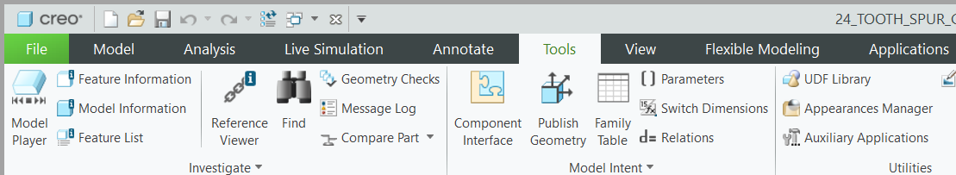
Figure 10a
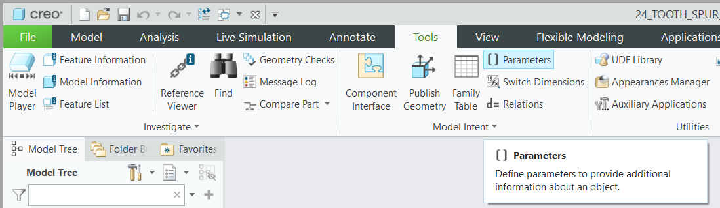
Figure 10b
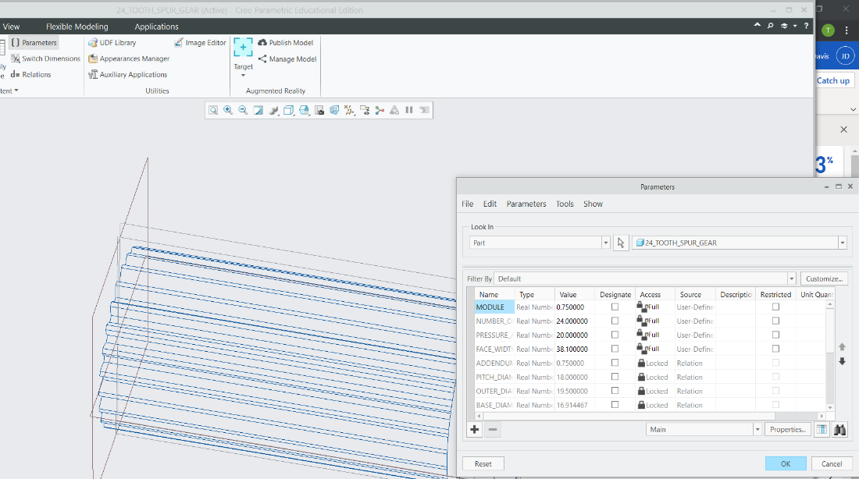
Figure 10c
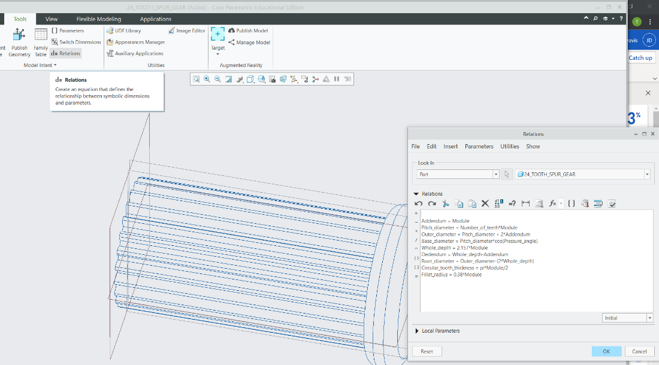
Figure 10d
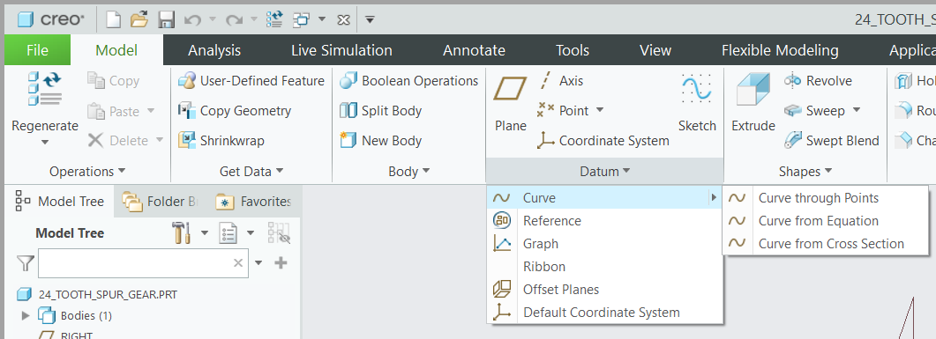
Figure 10e
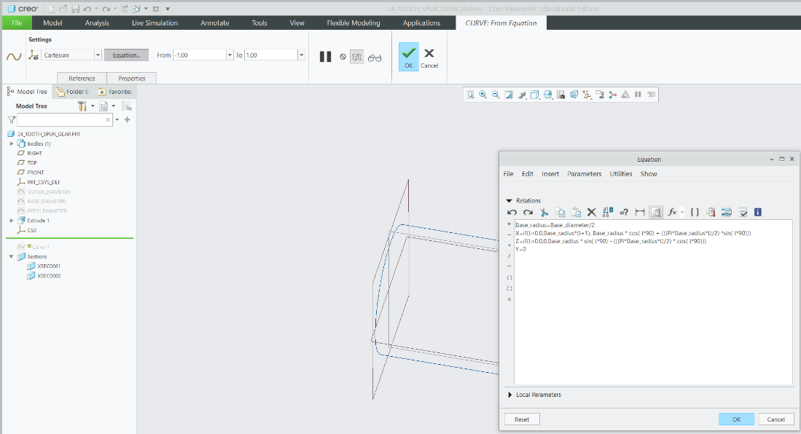
Figure 10f
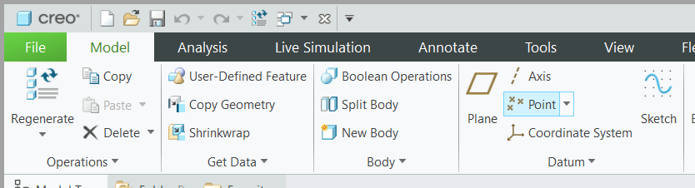
Figure 10g
After saving you can save a copy of the part and set it as an STL file. From here you can upload the file to whatever slicing software you have. For this part you will set the layer thickness to whatever is appropriate for your printer, set the wall thickness to between 2.8 and 3.2 mm (about 0.13 in) and set the infill to 30%. This is the setting we used during testing. For this part support structures are needed for the holes and to support the structure during the printing process. This part should be centered with the bottom of the part on the platform. The way the part is oriented is shown below in Figure 12.

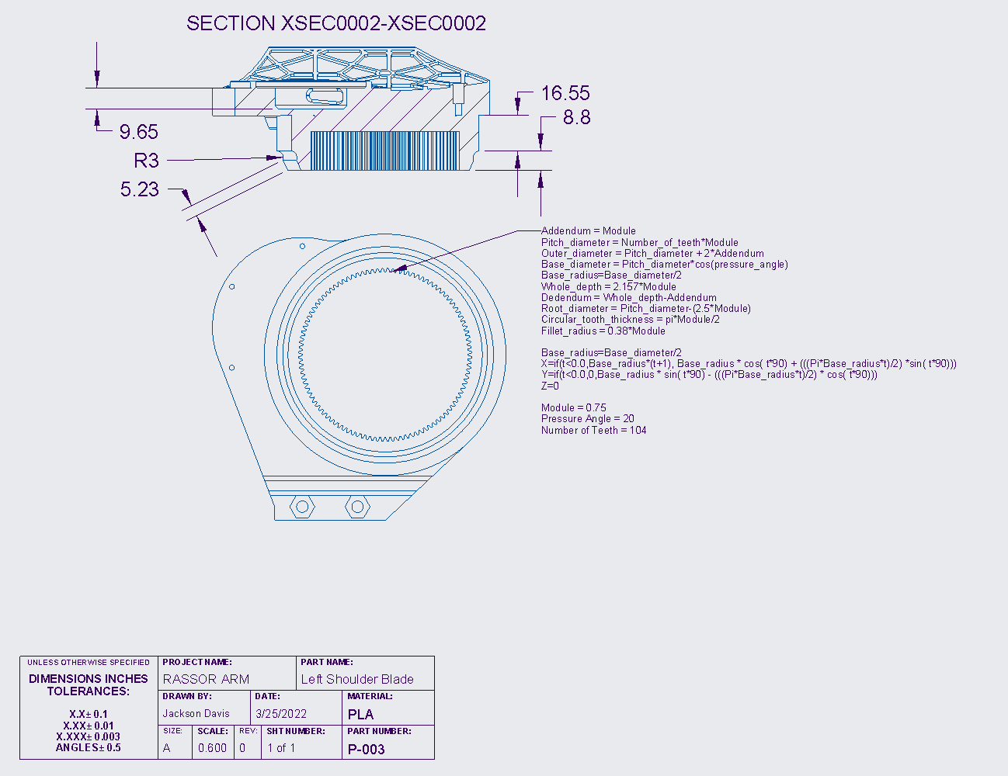
Figure 11: Drawing of the Left Shoulder Blade
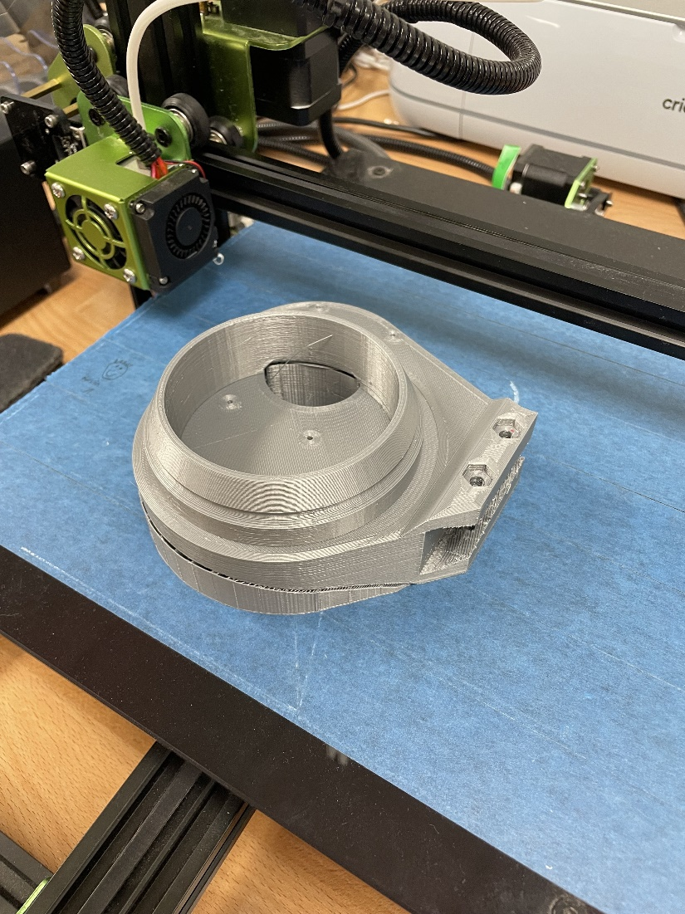
Figure 12: 3D-Print Layout of Left Shoulder Blade
Below in Figure 13 is the Left Bearing, it connects to the Left Shoulder Blade and is the second half of the left bearing that is used to reduce friction in the system and to keep the entire system in line. The bearing carries no load. The part’s dimensions are shown and can be used to recreate the part in Creo.
Creating the part in Creo starts by selecting the bottom plane and drawing the overall profile of the bearing that can be seen if you look at the part from the front view. Next, you can select the drawing you just made and extrude it. Note that the part's external holes are oriented in a specific way. 3 holes are arranged to where one is at the bottom dead center and the remaining two flanks on either side 90 degrees from the first hole. The remaining 4 holes are placed 40 degrees from the two flanking holes. After the extrusion is made you can select different surfaces and make the proper extrusions to subtract material. You can also use the revolve tool to aid in removing material.
After the part is finished you can save it. After saving you can save a copy of the part and set it as a STL file. From here you can upload the file to whatever slicing software you have. For this part you will set the layer thickness to whatever is appropriate for your printer, set the wall thickness to between 2.4 mm (about 0.09 in) and set the infill to 20-25%. This is the setting we used during testing. For this part support structures are not needed. This part should be centered with the bottom of the part on the platform. The way the part is oriented is shown below in Figure 14.
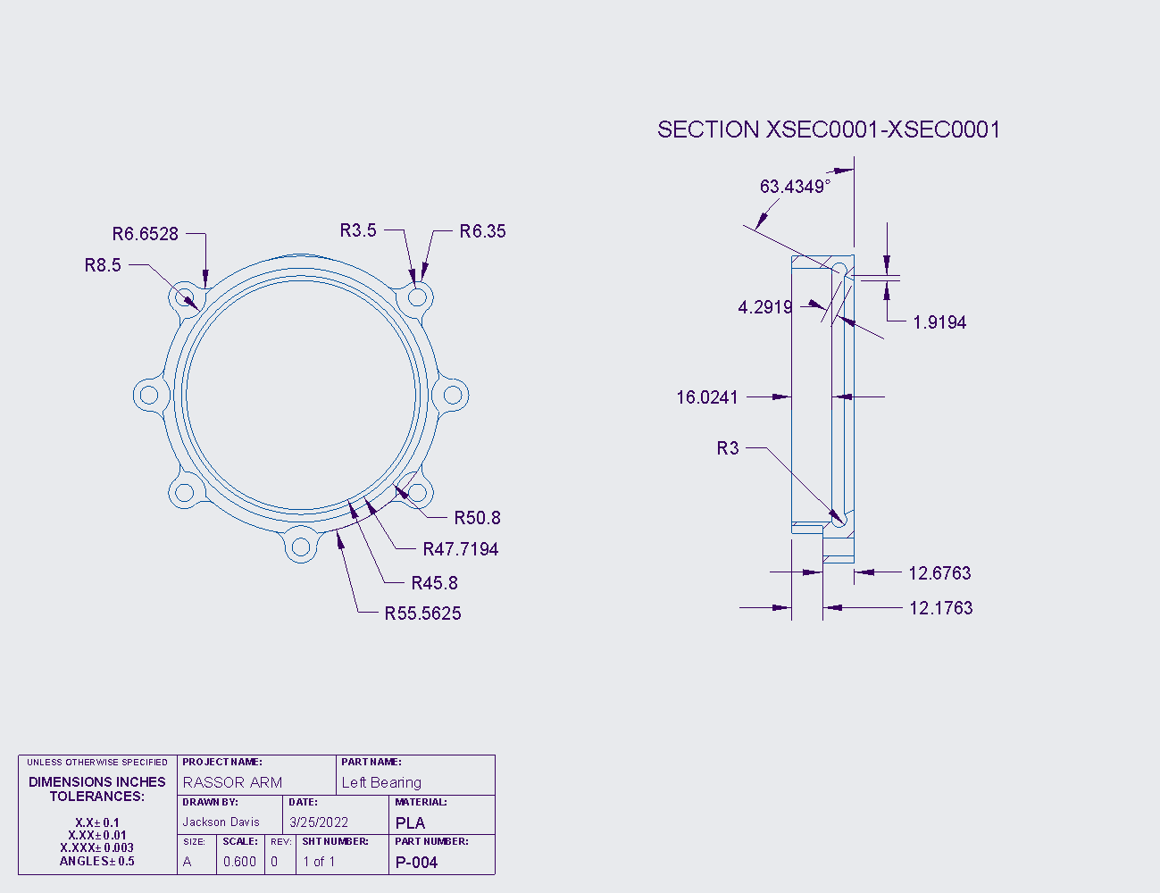
Figure 13: Drawing of the Left Bearing
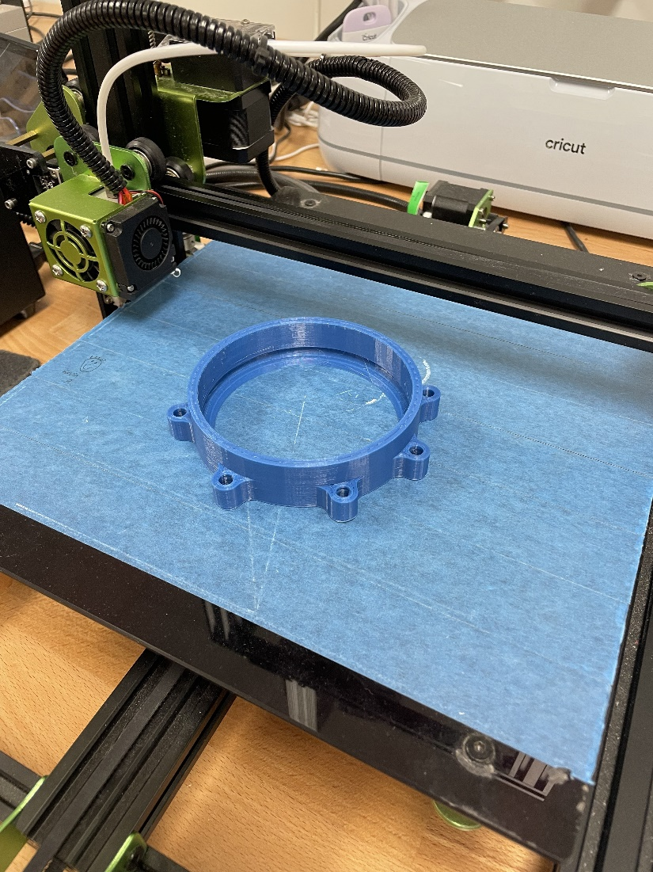
Figure 14: 3D-Print Layout of Left and Right Bearing
Below in Figure 15 is the Right Bearing, it connects to the Right Shoulder Blade and is the second half of the Right bearing that is used to reduce friction in the system and to keep the entire system in line. The bearing carries no load. The part’s dimensions are shown and can be used to recreate the part in Creo.
Creating the part in Creo starts by selecting the bottom plane and drawing the overall profile of the bearing that can be seen if you look at the part from the front view. Next you can select the drawing you just made and extrude it. Note that the parts external holes are oriented a specific way. 3 holes are arranged to where one is at bottom dead center and the remaining two flank either side 90 degrees from the first hole. The remaining 4 holes are placed 40 degrees from the two flanking holes. After the extrusion is made you can select different surfaces and make the proper extrusions to subtract material. You can also use the revolve tool to aid in removing material.
After the part is finished you can save it. After saving you can save a copy of the part and set it as a STL file. From here you can upload the file to whatever slicing software you have. For this part you will set the layer thickness to whatever is appropriate for your printer, set the wall thickness to between 2.4 mm (about 0.09 in) and set the infill to 20-25%. This is the setting we used during testing. For this part support structures are not needed. This part should be centered with the bottom of the part on the platform. The way the part is oriented is shown below in Figure 14.
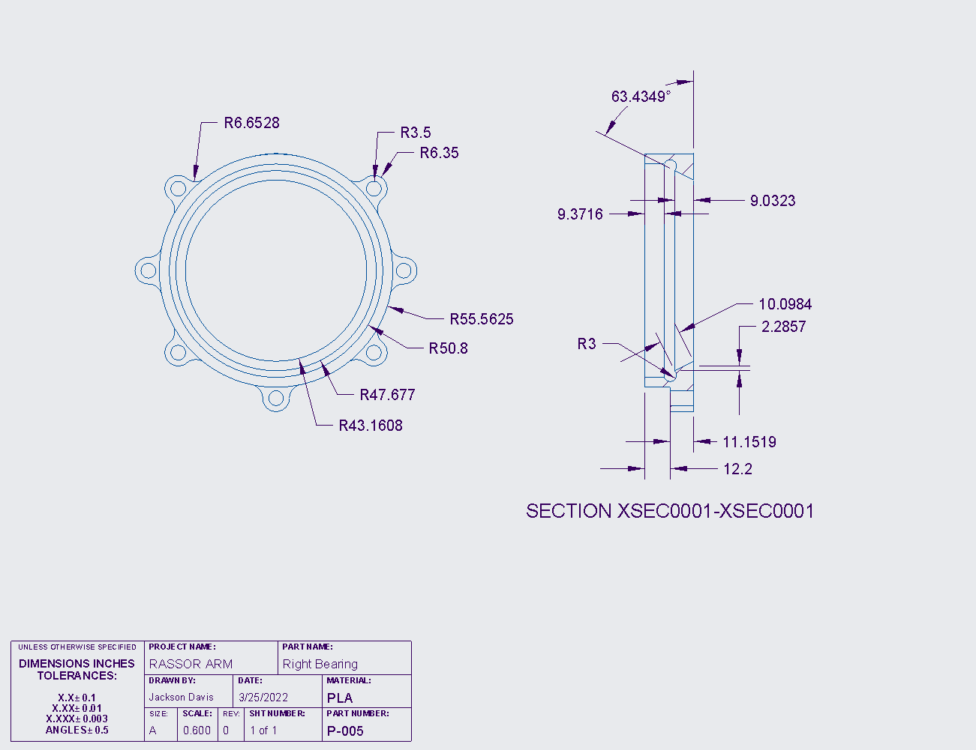
Figure 15: Drawing of the Right Bearing
Below in Figure 16 is the Motor Mount, it holds the motor in place during operation and serves as a mount for the arm. The Motor Mount carries a load when the system is running. The part’s dimensions are shown and can be used to recreate the part in Creo.
Creating the part in Creo starts by selecting the bottom plane and drawing the overall profile of the Motor mount that can be seen if you look at the part from the bottom view. Next you can select the drawing you just made and extrude it. Note that the parts external holes are oriented a specific way. 3 holes are arranged to where one is at bottom dead center and the remaining two flank either side 90 degrees from the first hole. The remaining 4 holes are placed 40 degrees from the two flanking holes. After the extrusion is made you can select different surfaces and make the proper extrusions to subtract material. You can also use the revolve tool to aid in removing material.
To make the flange that holds the arm you can make a drawing on the front plane that matches the profile to the interior of the flange with an external offset of 3.175mm (about 0.12 in). You can then extrude this drawing. By using the extrude tool you can make the flange by removing and adding material.
After the part is finished you can save it. After saving you can save a copy of the part and set it as an STL file. From here you can upload the file to whatever slicing software you have. For this part, you will set the layer thickness to whatever is appropriate for your printer, set the wall thickness to between 2.8-3.2 mm (about 0.13 in) (about 0.13 in), set the infill to 30%. This is the setting we used during testing. For this, part support structures are needed. This part should be centered with the bottom of the part on the platform. The way the part is oriented is shown below in F in Figure 17.
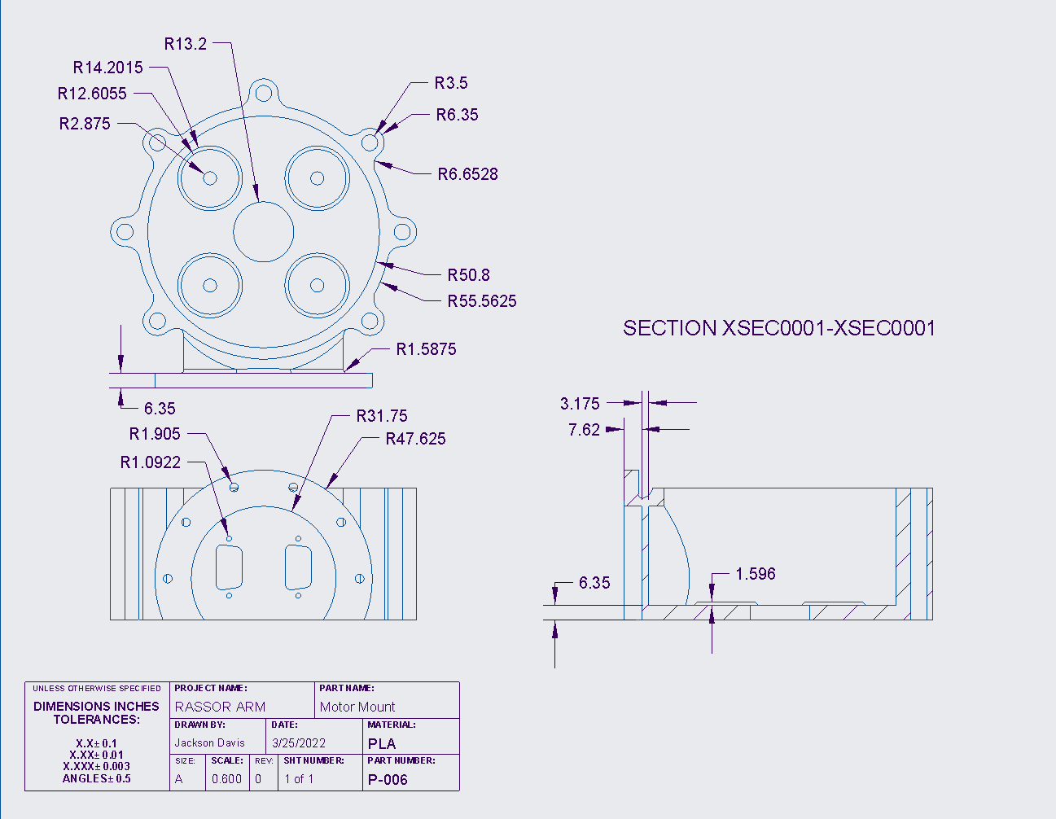
Figure 16 Drawing of the Motor Mount
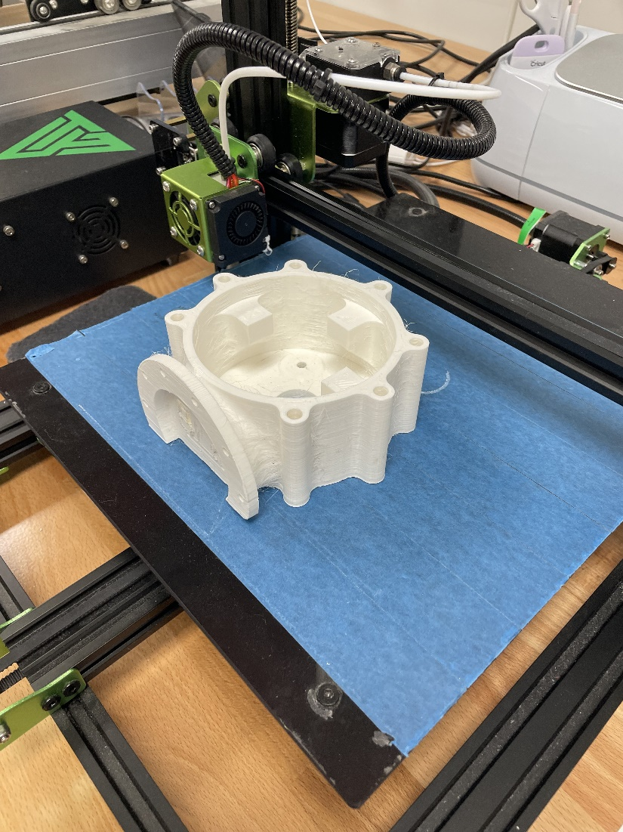
Figure 17 3D-Print Layout for Motor Mount
Below in Figure 18 is the Sun Gear, it is the input gear to the system and attaches directly to the Motor. The part carries a small load in comparison to the rest of the load bearing parts. The part’s dimensions are shown and can be used to recreate the part in Creo.
Creating the part in Creo starts by selecting the bottom plane and drawing a circle to the outer diameter given and extruding it. Next you can upload the parameters given at the bottom of the note on the drawing by selecting the tool tab and then selecting parameters. Then you can set the relations which are given at the top of the note by selecting the tool tab again and selecting relations after. From here you can use these parameters to make the outer diameter, root diameter, pitch diameter, and base diameter. With these diameters you can use the datum line tool to create an involute profile for the teeth. You can do this by selecting the line datum and selecting datum line by equation. The equation that you will use is the last portion of the not given in the drawing. After making the involute curve you can set a drawing that starts from the edge of the involute curve and travels along the pitch diameter until it reaches the circular tooth thickness. You can then place a datum point halfway on the line. With this datum point you can mirror the involute line to the other side and finish the profile of the gear tooth. Next you can extrude this profile and pattern is around the center axis of the part. There should be 24 teeth for this part. After the part is finished you can save it.
After saving you can save a copy of the part and set it as an STL file. From here you can upload the file to whatever slicing software you have. For this part you will set the layer thickness to whatever is appropriate for your printer, set the wall thickness to between 2.8-3.2 mm (about 0.13 in) and set the infill to 30-75%. This is the setting we used during testing. For this part support structures are needed. This part should be centered with the bottom of the part on the platform. The way the part is oriented is shown below in Figure 19.
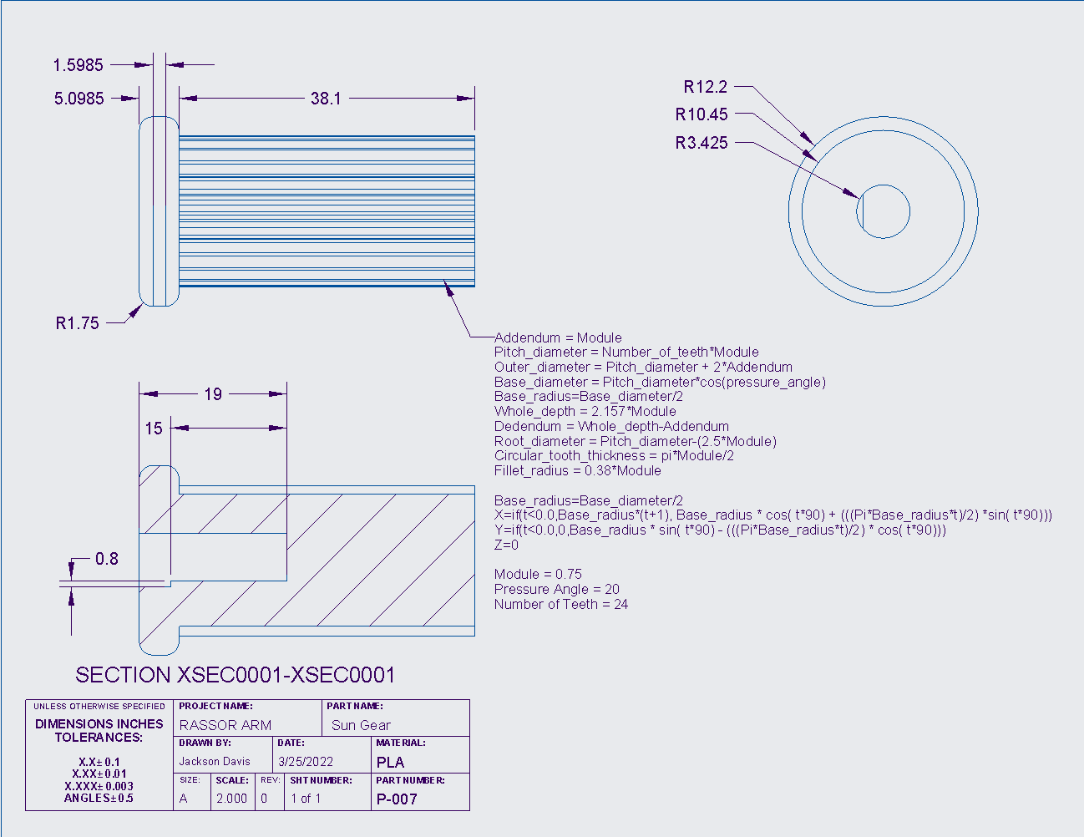
Figure 18: Drawing of the Sun Gear
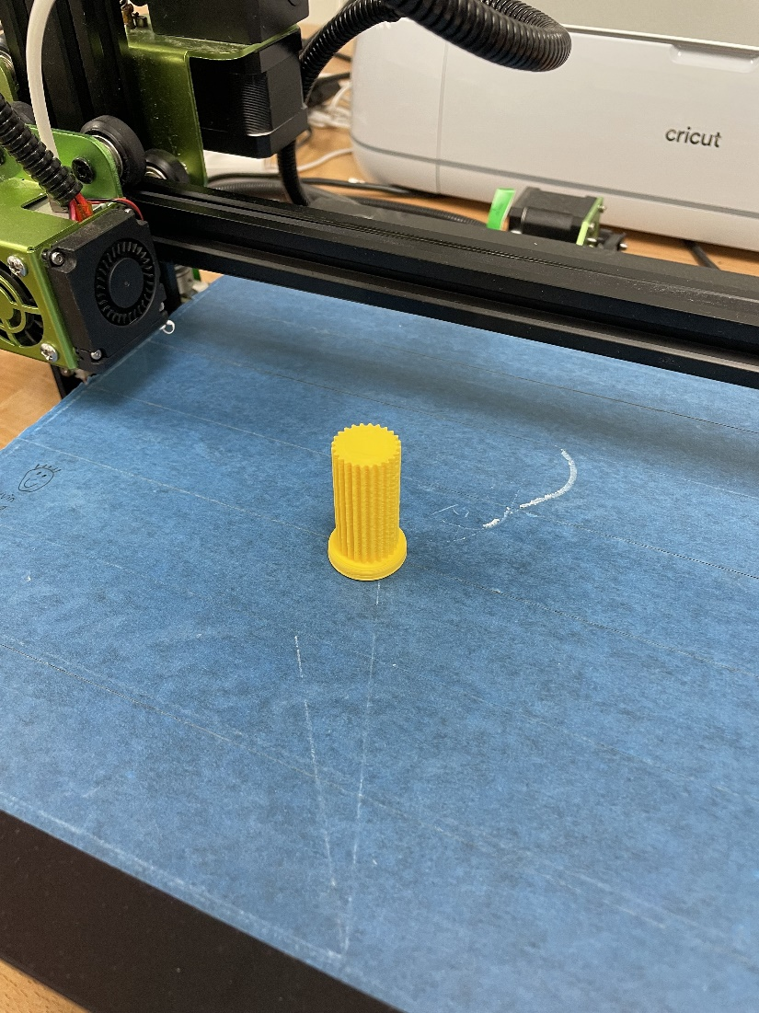
Figure 19: 3D-Print Layout for Sun Gear
Below in Figure 20 is the Planet Gear, it is 1 of 3 planet gears that are used to press the harmonic gear to the same diameter as the right shoulder blade’s gear diameter. There is a spring force from the harmonic gear and a torque from the gearbox’s operation that is applied to the planetary gears generating a larger load than what the sun gear experiences. The part’s dimensions are shown and can be used to recreate the part in Creo.
Creating the part in Creo starts by uploading the parameters given at the bottom of the note on the drawing by selecting the tool tab and then selecting parameters. Then you can set the relations which are given at the top of the note by selecting the tool tab again and selecting relations after. From here you can use these parameters to make the outer diameter, root diameter, pitch diameter, and base diameter. With these diameters you can use the datum line tool to create an involute profile for the teeth. You can do this by selecting the line datum and selecting datum line by equation. The equation that you will use is the last portion of the not given in the drawing. After making the involute curve you can set a drawing that starts from the edge of the involute curve and travels along the pitch diameter until it reaches the circular tooth thickness. You can then place a datum point halfway on the line. With this datum point you can mirror the involute line to the other side and finish the profile of the gear tooth. Next you can extrude this profile and pattern is around the center axis of the part. There should be 40 teeth for this part.
After the part is finished you can save it. After saving you can save a copy of the part and set it as an STL file. From here you can upload the file to whatever slicing software you have. For this part you will set the layer thickness to whatever is appropriate for your printer, set the wall thickness to between 2.8-3.2 mm (about 0.13 in) and set the infill to 30-75%. This is the setting we used during testing. For this part support structures are not needed. This part should be centered with the bottom of the part on the platform. The way the part is oriented is shown below in Figure 21.
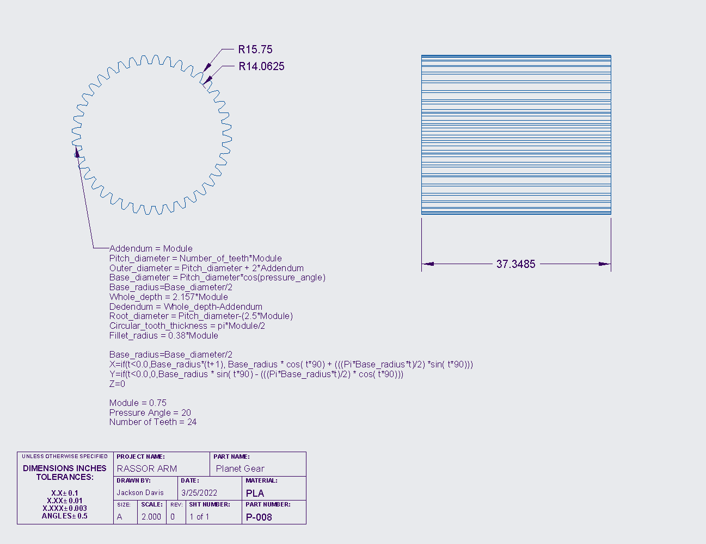
Figure 20: Drawing of Planetary Gear
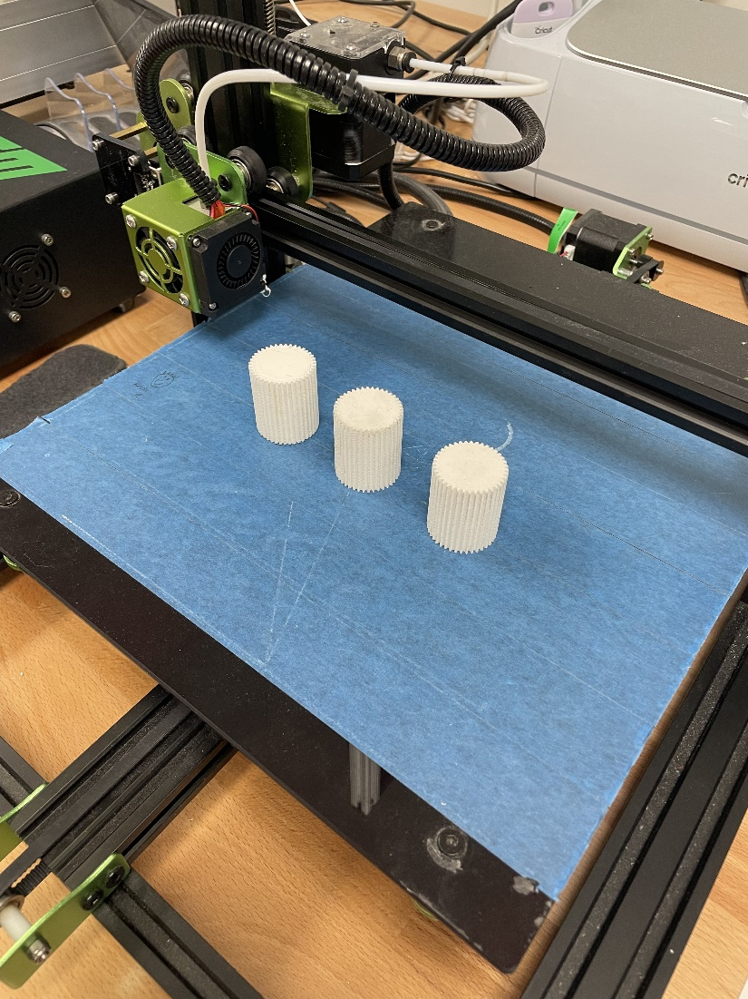
Figure 21: 3D-Print Layout for Planet Gears
Below in Figure 22 is the Harmonic Gear, it is our output gear and drives the entire system. This part experiences the most load in the entire system. The part’s dimensions are shown and can be used to recreate the part in Creo.
Creating the part in Creo starts by drawing the overall profile of the Harmonic Gear that can be seen if you look at the part from the bottom view. Next you can select the drawing you just made and extrude it. Note that the parts external holes are oriented a specific way. 3 holes are arranged to where one is at bottom dead center and the remaining two flank either side 90 degrees from the first hole. The remaining 4 holes are placed 40 degrees from the two flanking holes.
Next you can draw the profile of the compliant mechanism given in the drawing. This profile can be extruded and patterned with a total of 16 profile holes.
Next you can upload the parameters given at the bottom of the note on the drawing by selecting the tool tab and then selecting parameters. Then you can set the relations which are given at the top of the note by selecting the tool tab again and selecting relations after. From here you can use these parameters to make the outer diameter, root diameter, pitch diameter, and base diameter. With these diameters you can use the datum line tool to create an involute profile for the teeth. You can do this by selecting the line datum and selecting datum line by equation. The equation that you will use is the last portion of the not given in the drawing. After making the involute curve you can set a drawing that starts from the edge of the involute curve and travels along the pitch diameter until it reaches the circular tooth thickness. You can then place a datum point halfway on the line. With this datum point you can mirror the involute line to the other side and finish the profile of the gear tooth. Next you can extrude this profile and pattern is around the center axis of the part. There should be 100 teeth for this part.
Finally, you can make the flange that holds the arm by setting a plane on the front plane and offsetting it to the outer shell of the harmonic gear. On this plane you can make a drawing that matches the profile to the interior of the flange with an external offset of 3.175mm (about 0.12 in). You can then extrude this drawing. By using the extrude tool you can make the flange by removing and adding material.
After the part is finished you can save it. After saving you can save a copy of the part and set it as a STL file. From here you can upload the file to whatever slicing software you have. For this part you will set the layer thickness to whatever is appropriate for your printer, set the wall thickness to 3.2 mm (about 0.13 in) and set the infill to 30%. This is the setting we used during testing. For this part support structures are needed. This part should be centered with the bottom of the part on the platform. The way the part is oriented is shown below in Figure 23.

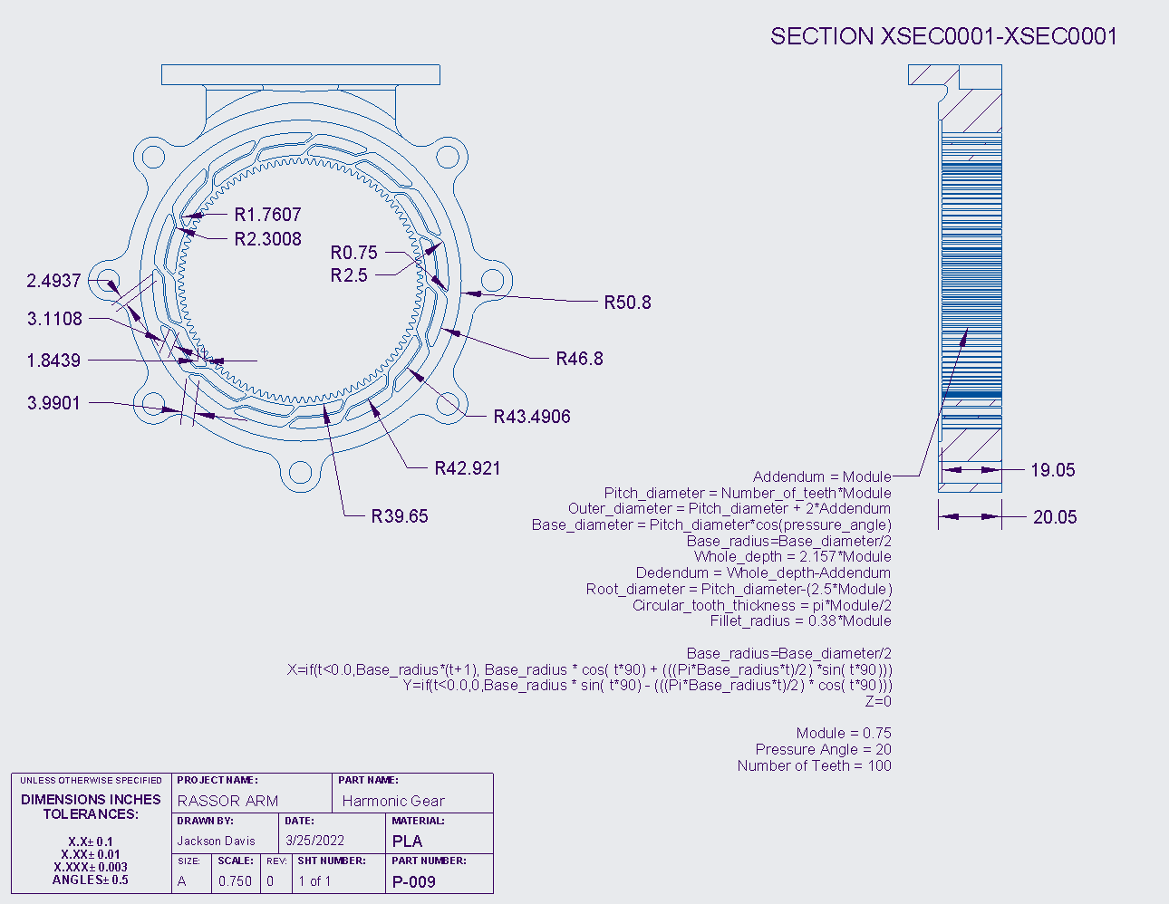
Figure 22: Drawing of Harmonic Gear
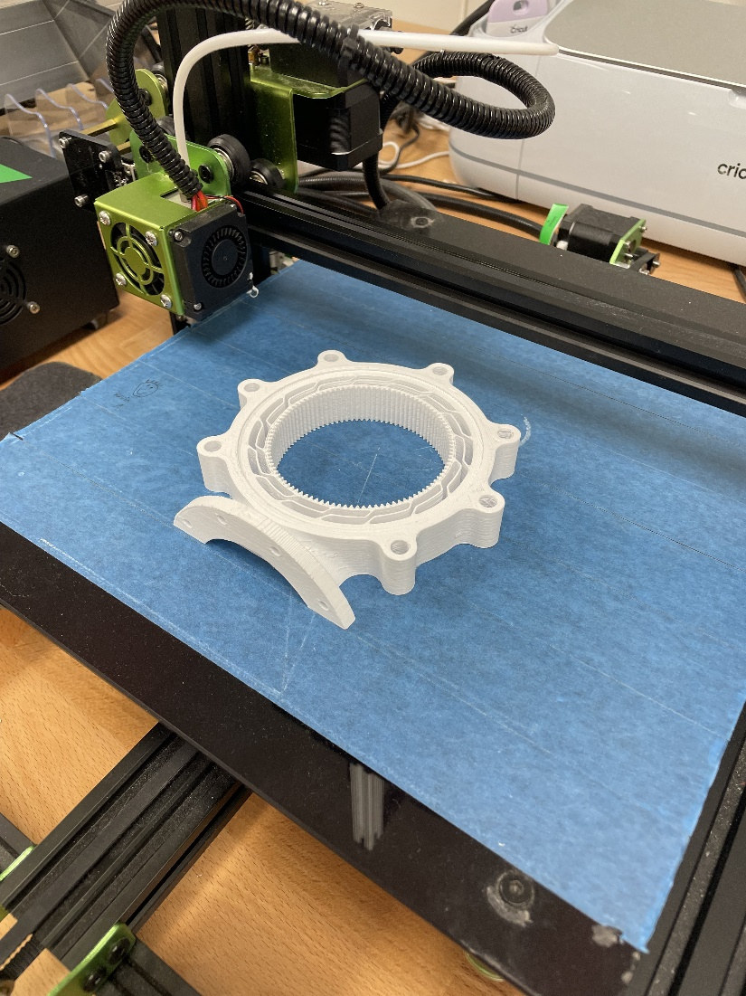
Figure 23: 3D-Print Layout of Harmonic Gear
After all parts have been made you can make an assembly and add the parts that you have made. By setting the proper constraints the assembly should eventually look like Figure 24a-c.
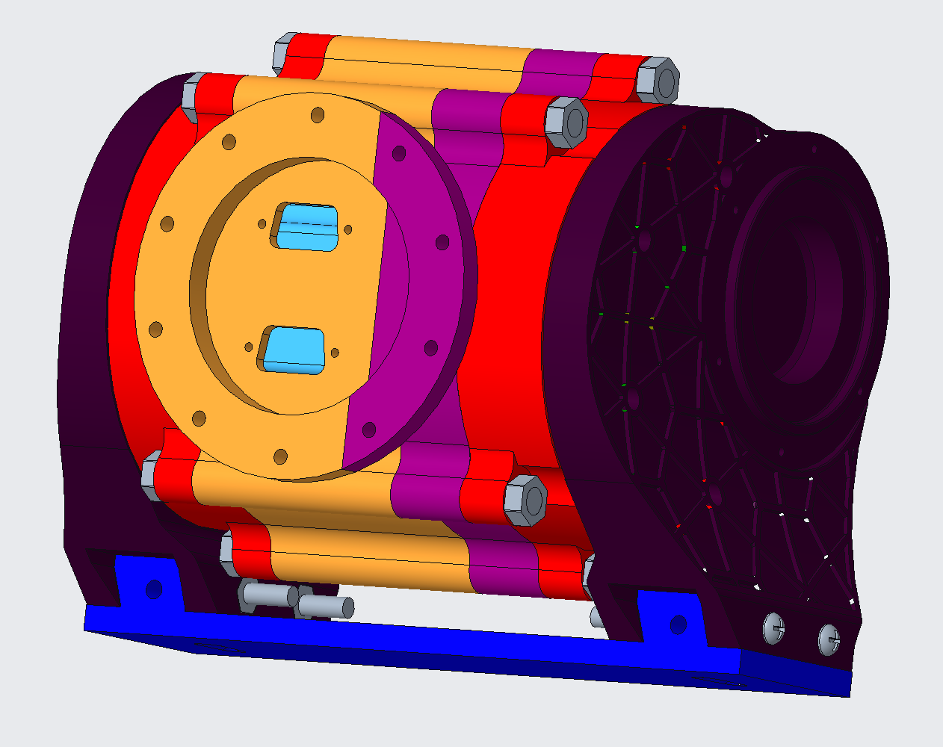
Figure 24a
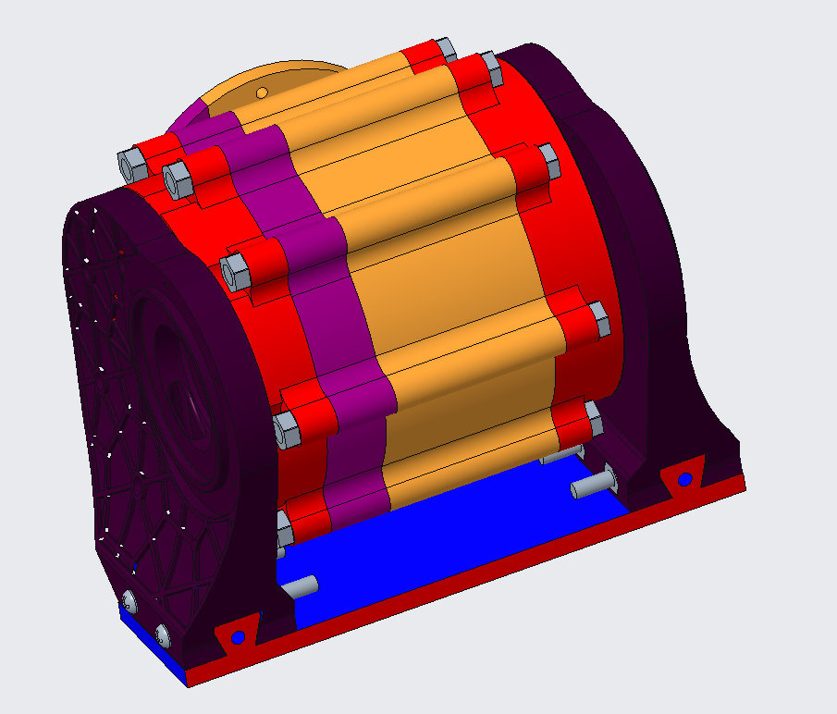
Figure 24b
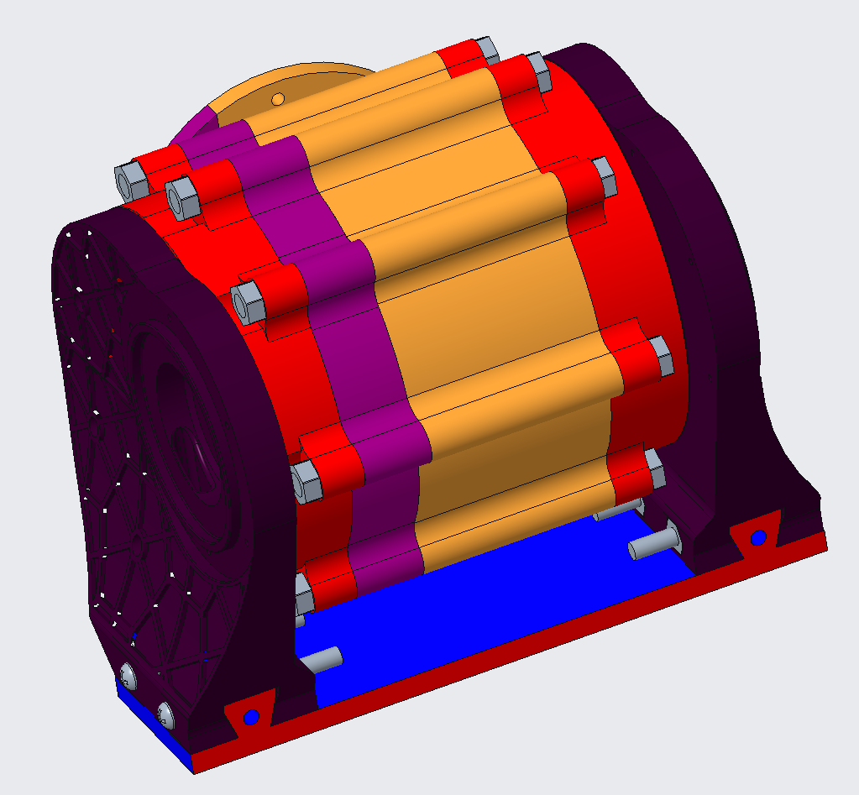
Figure 24c
The additional parts including the motor and nuts and bolts can be purchased off Amazon and Home Depot However they can be ordered from McMaster-Carr and “Other Vendor”. The screws and bolts used were 4 #8-32x1-1/4in Flat head screws, #8-32x1-1/2in Phillips head screws, and an 11mmx5in bolt. The nuts used were a #8-32 nut and an 11mm nut.
The stepper motor is a Nema 23 that puts out 1.9 Nm of torque. It is 77mm in depth with a quarter-inch output shaft. We are running this motor with a RAMPS board. We are also using standard 6mm BB’s that can be purchased at Walmart for the balls for our ball bearings.

Printing Parts
All STL files for this project can be found in the folder below:
https://drive.google.com/drive/folders/1ramL2J5DWkxRTX-dNWjKdK5XjYMY8uas?usp=sharing
Note: Need to print 3 of the “40_tooth_planet_gear” to complete the build
All parts were printed on a Dremel 3D45 Idea Builder using 1.75mm PLA filament (Standard 4mm should work just as well). Below are the parameters used on all the prints:
- Nozzle Diameter: 0.4 mm
- Layer Thickness: 0.3 mm
- Shell Thickness: 1.2 mm (Most parts can be printed with lower thickness to save time)
- Infill: 25%
- Infill pattern: Honeycomb (cubic)
- Extruder Temperature: 205 °C
- Heated Bed Temperature: 55 °C (If no heated bed, painter’s tape is recommended)
- Fan Speed: 100%
- Filament flow: 95%
- Supports: Everywhere
- Support Type: Grid
- Bottom Layer Speed: 10 mm/s
- Print Speed: 40 mm/s
- Traveling Speed: 130 mm/s
- Retraction Distance: 0.8 mm (Stringing still occurs, but with no structural effects)
- Minimal Layer Time: 5 seconds
Figures 5, 9, 12, 14, 17, 19, 21, and 23 demonstrate the correct orientation for printing all parts.
Post processing
- Remove all supports and sand where the supports were connected to make the surfaces smooth.
- Depending on the printer used, sanding will need to be done to the surfaces in contact with the print bed, especially if that surface has gear teeth. Gear teeth in contact with the print bed often print too large on the base layer and need to be sanded or filed down to allow for proper meshing. This is important for the harmonic gear and the planet gears.
Assembly:
Place planet gears (white) around the edge of the harmonic gear (black) and press sun gear (yellow) into the middle of them.
Try to equally space gears around the ring.
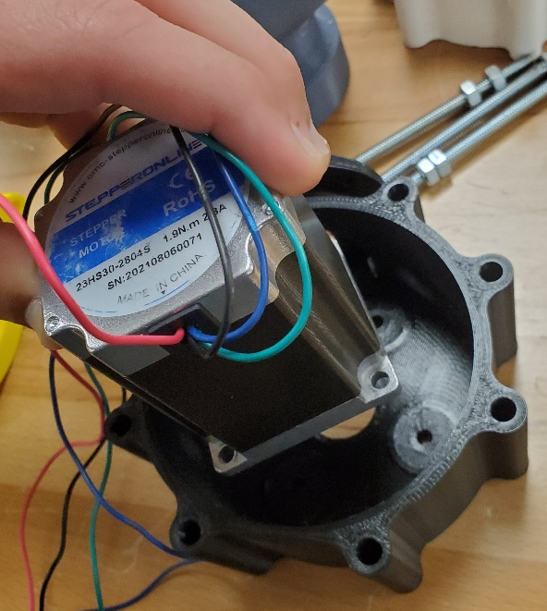
Place NEMA23 stepper motor into housing and line up the screw holes.

Place screws into the housing so that the heads are flush.
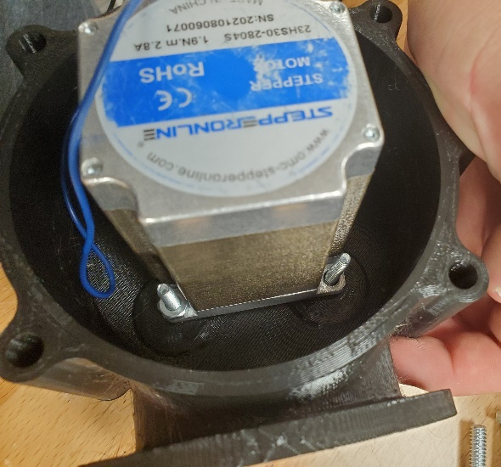
Put nuts on the back end of all four bolts and tighten.
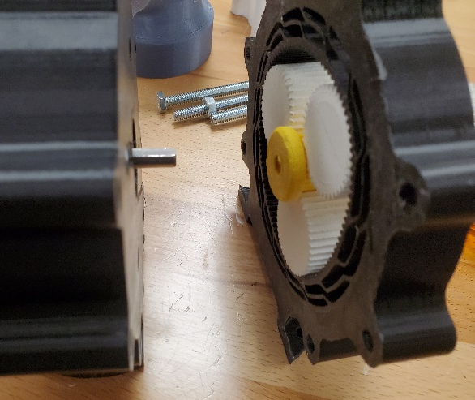
Slide shaft into sun gear (pay attention to orientation of all parts, and line up integrated keyway).
Slide the harmonic gear and the housing flush to each other.
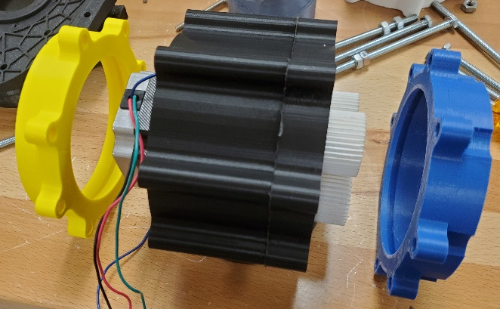
Slide bearing tracks into place, make sure all bolt holes align.
Slide all bolts into housing with threaded end going out the dimpled side.
Place nuts on end of bolts and tighten (do not over tighten, just over finger tightness should suffice).
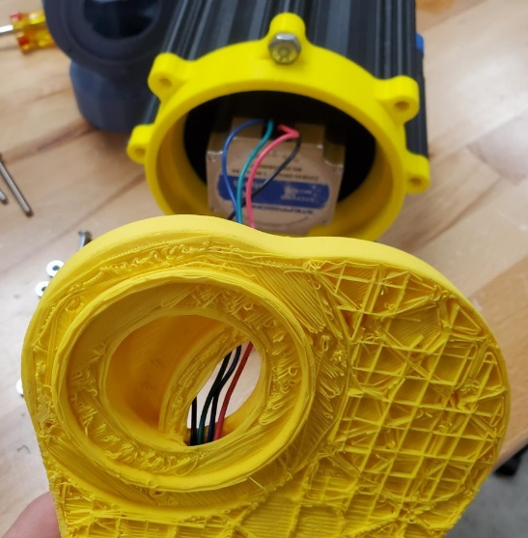
Route stepper motor wires through the hole in shoulder blade.
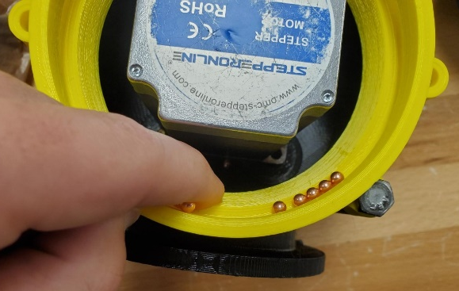
Fill bearing track with 4.5 mm bb’s.
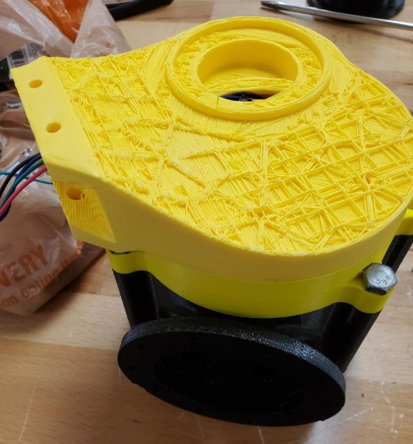
Place shoulder blade on top (MAINTAIN PRESSURE SO THAT BBS DO NOT FALL OUT DURING FURTER ASSEMBLY)
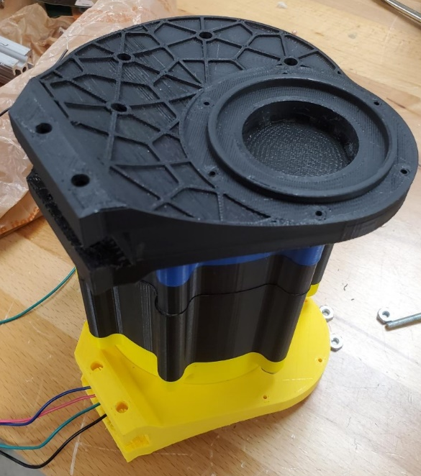
Repeat process in the other bearing track/shoulder blade
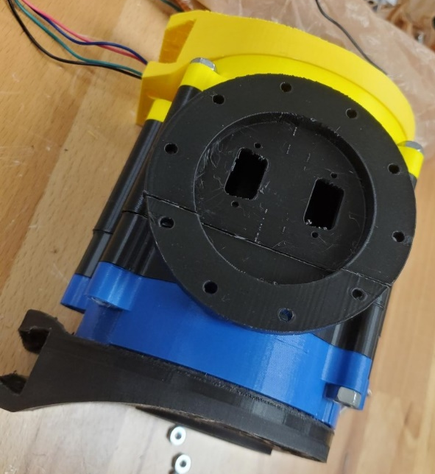
Assembly of the shoulder is complete; you may mount the shoulder system to the body at this point.
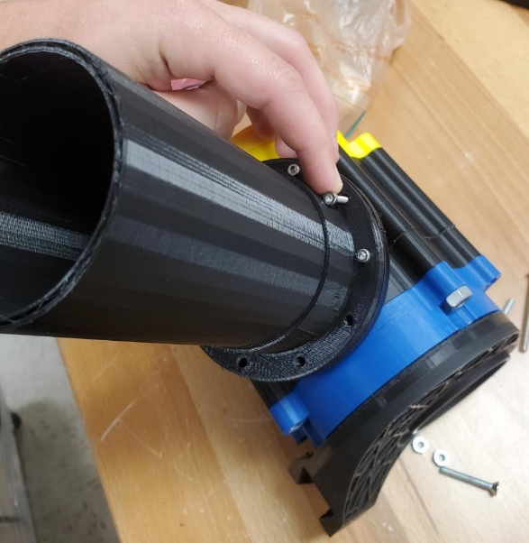
Place and fasten screws around the perimeter of the arm flange
If assembling permanently add glue inside the ring of the knuckle, otherwise a press fit should hold it in place well.
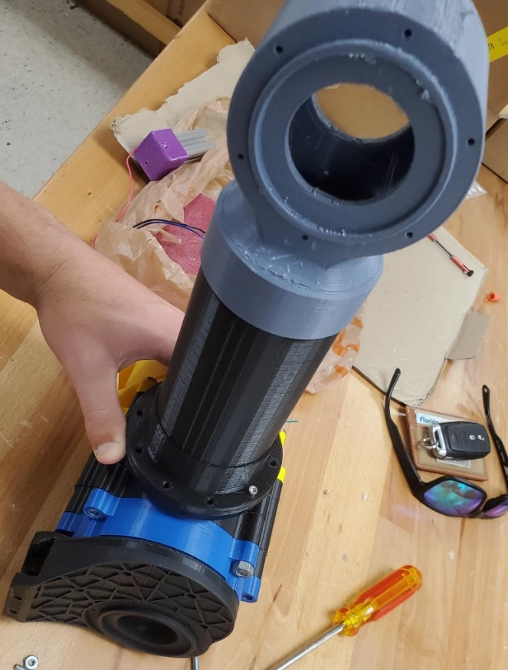
The complete assembly should look like this, ensure the knuckle is perfectly parallel to the shoulder when mounted on the arm before assembling the drum.

Operation
Wiring and Code with a Ramps Board
For this assembly, a RAMPS 1.4, Arduino Mega 2560, (DRIVERS), and Nema 23 are needed. The first step is to align the RAMPS 1.4 pins on top of the Arduino Mega 2560 and join them together.
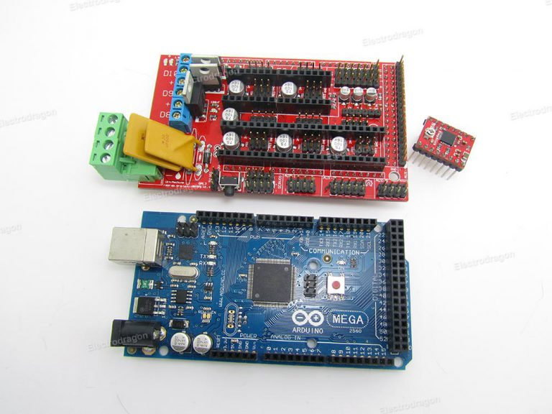
Figure 25
Next place 3 jumpers into the MS 1, 2, and 3 set of pins in X section.
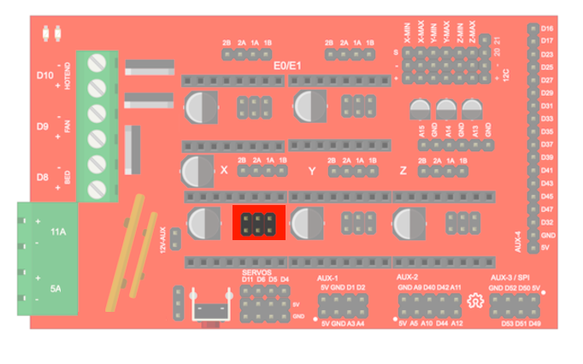
Figure 26
Then connect the driver to these set of pins. Make sure the screw is point away from the power supply.
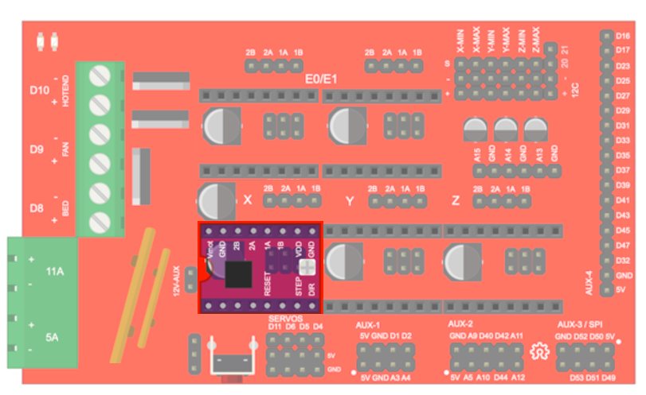
Figure 27
After, connect the stepper motor to 2A 1A 2B 1B with their respective wires in X section. Performing a diode test with two of the wires will tell you if they are a pair.
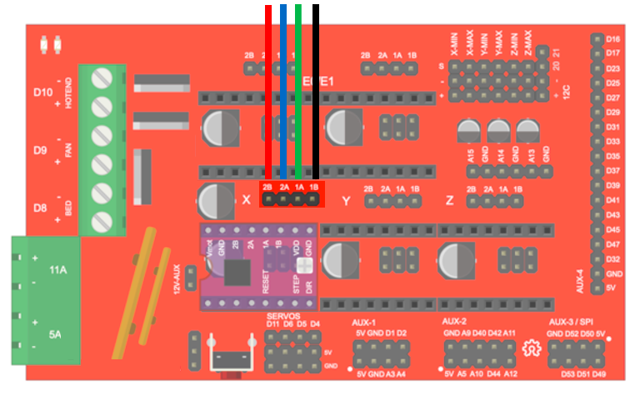
Figure 28
Lastly, with no voltage and current, connect the power supply.
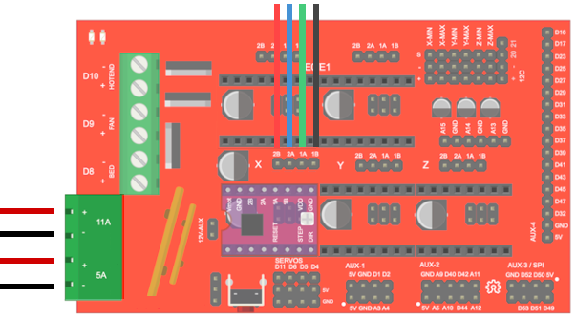
Figure 29
Hook up the Arduino to the computer. When you do, the RAMPS board will signal a light letting you know it is connected. Download https://marlinfw.org/meta/download/ . This code allows the Arduino to communicate to the RAMPS board. Upload the code the Arduino.
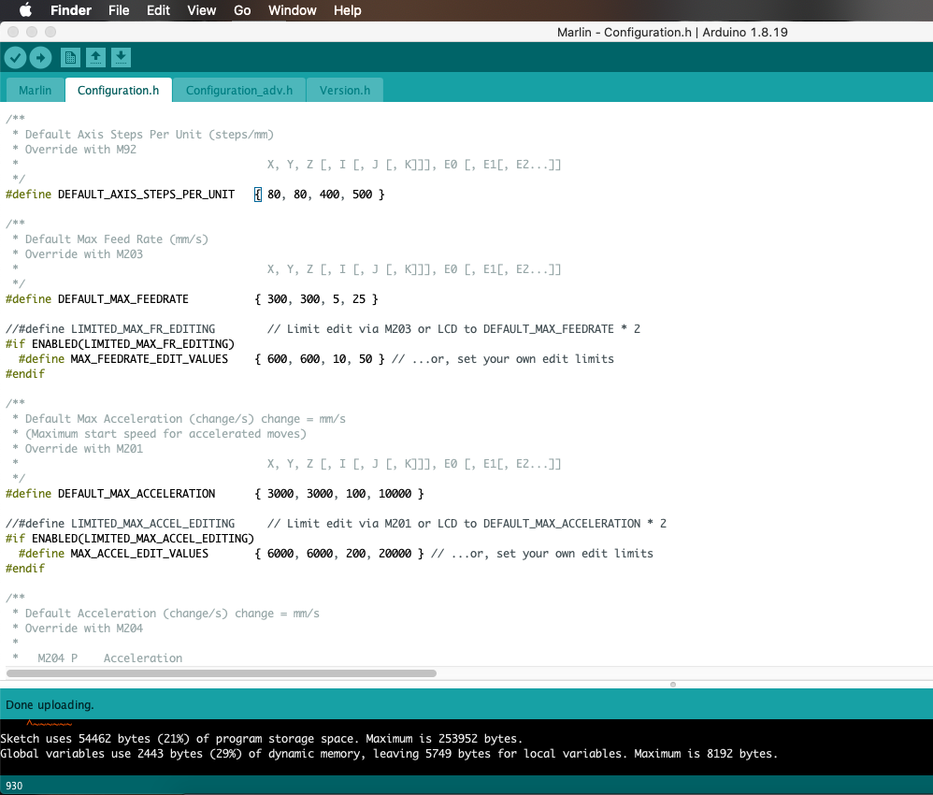
Figure 30: Arduino Code for Ramps Board
Under tools make sure the right board: Arduino Mega or Mega 2560, processor: ATmega2560 (Mega 2560), and port are selected.
Download prontoface; This software can control up to 6 stepper motors. Make sure that the right port is selected and connect to the device.
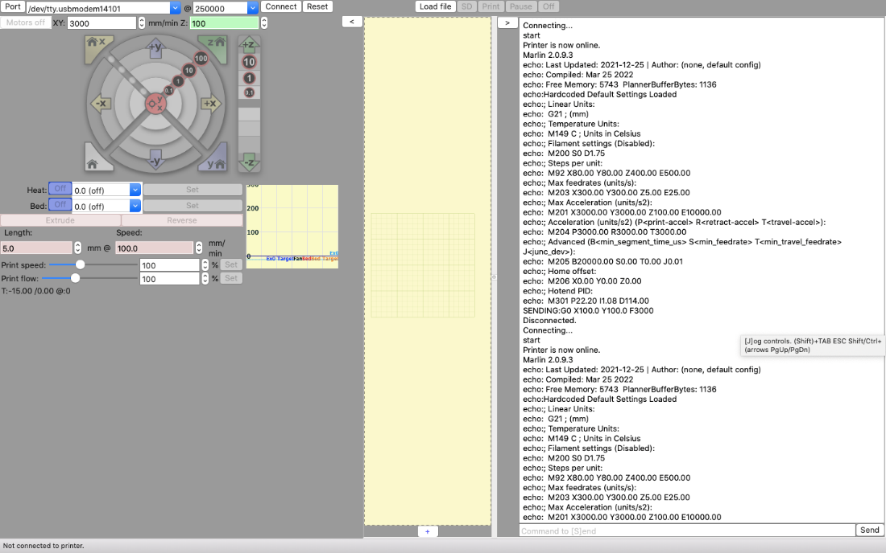
Figure 31: Prontoface Code
Wiring and Code without a Ramps Board
For running this assembly without a ramps board, you will need a Nema 23 stepper motor, L298N Motor Driver, and Arduino Mega. In Figure 32, it shows the wiring diagram for this set up. You will have to ground the motor driver to both power supply and the Arduino board. It will also be hooked up to a positive charge of the power supply apply 12 Volts at 1.2 Amperes. To drive the motor driver then the jumpers must be on both ENA and ENB. The Arduino needs four digital pins to be hooked up to the motor driver. The pins that were chosen are 22-25. Pin 22 is connected to IN1and going down to pin 25 connected to IN4. Lastly, the stepper motor must be connected to the motor driver. Start with A1 being connected to output 1, A2 being connected to output 2, B1 being connected to output 4, and finally B2 being connected to output 3. Once this is all set up the Arduino code must be written to therefore run the motor and cause the arm to move.

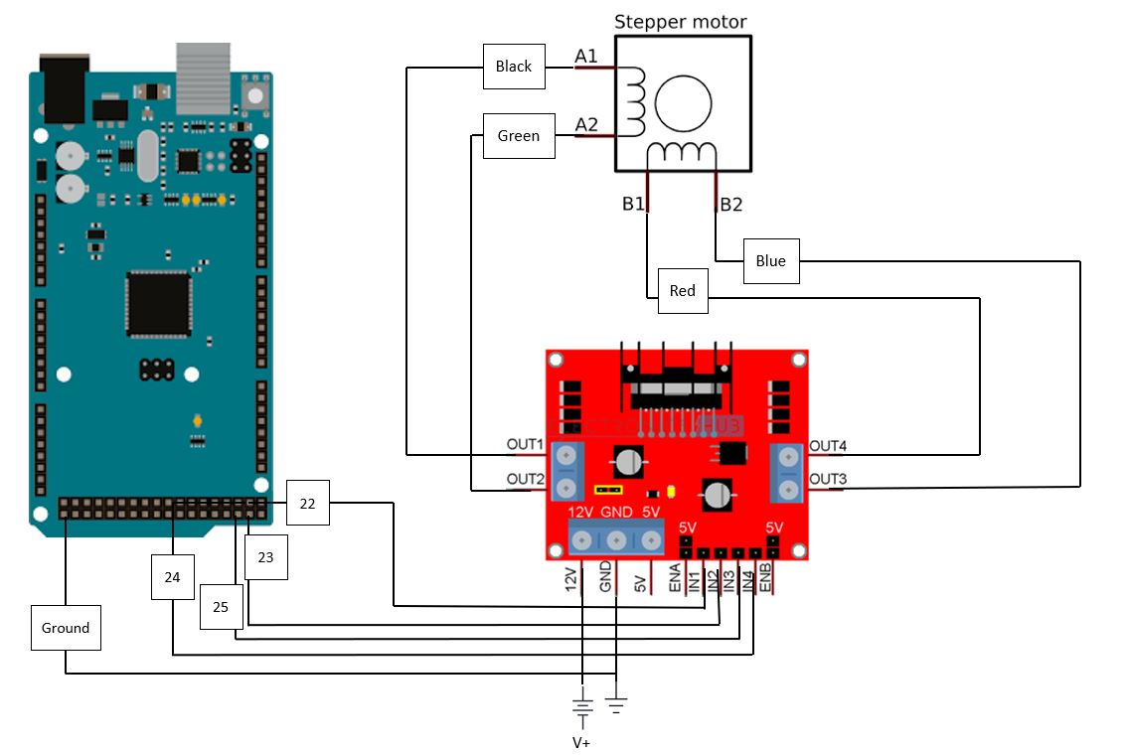Figure 32: Wire Diagram
After the set-up is completed, code must be written so that the motor can move. In Figure 33, it shows the Arduino code that was used to run the motor. The library Stepper.h must be installed and used to run the motor. The code uses a count called ticks to know when to switch the arm from lifting to moving down. After 20 iterations the motor will move back down to go to its original position. This code was used to test the motor and the strength of the gearbox to figure out what alterations need to be made for the final project.
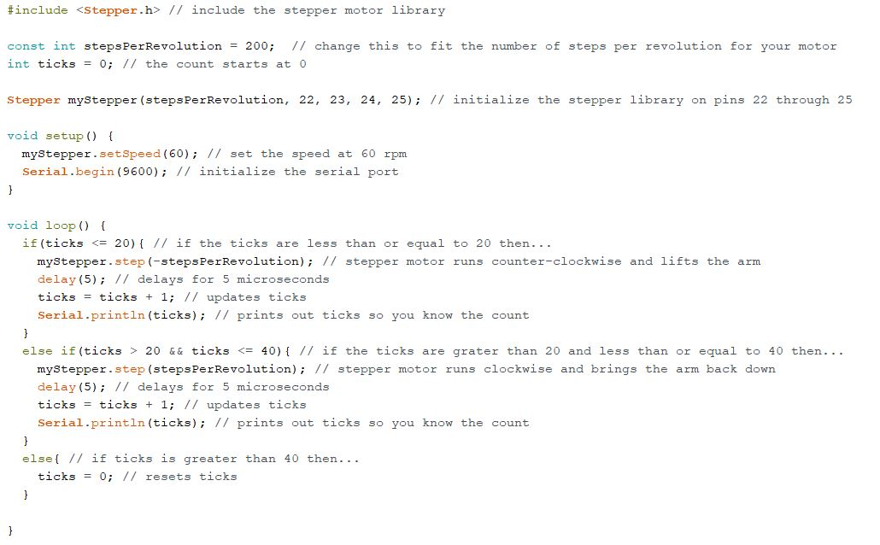Figure 33: Arduino Code

Troubleshooting
With many components, it is important to isolate each system.

Power Supply
The first system to access is the power supply; With a multimeter the voltage and current can be measured. The system is meant to run on 10 Volts and 1.3 Amps.
Make sure your voltage and current falls with the range of the ramps board and motor are manufactured to withstand. Be careful not to exceed the recommended voltage and current given by specification of the ramps board and motor. Exceeding the recommended voltage and current will result in damage to the component and others in the circuit. Keep in mind that current will heat up the components.

Circuit
If the power supply is working, the next system to investigate is the circuit. Be careful on short circuiting the system. This occurs when a positive charged (typically red) wire touches a ground wire (typically black).
Connect the ramps board to the power supply and check the output voltage and current. Make sure the code is uploaded to the Arduino board; if not the RAMPS board will not be able to communicate with the motor effectively.
Once established that the right voltage and current are flowing, turn off the power supply and connect the motor. Make sure the motor wires are connected to the right pins. Also ensure that the wires are properly adhered to the board.
After checking each wire placement, turn on the power supply. The motor should be spinning in the intended direction; A detachable tag (post it note, tape, etc.) can be attached to the shaft to visualize the direction of the motor. If the motor is not spinning in the desired direction, re-check the code and wiring. Note that the motor should be capable of spinning in both directions.

MOTOR
The design is intended for a stepper motor; A DC motor should not be used because it lacks the precision and torque a stepper motor can supply.
The stepper motor shaft should twist easily with force from a hand. If the stepper motor is not twisting with ease, the type of motor should be considered. A stepper motor that has permanent magnets will need more external force (twisting with your hand) than one without. The Nema 23 should twist with the force of a hand.
If the shaft is vibrating or shaking when it is connected, check if it is properly connected. Note that the driver might be overheating; If this is the case, let it cool and try again.
Take note when reading the specification of the motor that the given output torque will vary based on the supplied voltage and current supplied. A calibration can calculate the torque that the motor should be outputting.
Testing the motor’s torque can be conducted with a mount and scale. For this test, the motor should be grounded with a mount; this can be on a sturdy table. Then with an attached lever, the motor should be connected to the ramps board and power supply and powered on. With the lever on top of the scale, the motor will rotate and push down on the scale, resulting a force reading on the scale. The torque can then be calculated.

3D PARTS
Make sure the sun gear fits the motor shaft securely and is not slipping. If slipping occurs, the rest of the gearbox will not rotate; Therefore, check the shape of the hole. The flat surface should align with the motor's flat edge.
Note when 3D printing, holes should be slightly bigger than the required diameter to allow for tolerance. (All files included here have already accounted for this)
If creating STL files from the STEP/Creo files, ensure that your mesh has high resolution and quality; Failure to do so will print out the wrong shapes affecting the motion of the gear set. 3D printed gears will have lipping that need to be filed/sanded down to mesh correctly.

